REPUBLIQUE DU CAMEROUN
Paix – Travail - Patrie

REPUBLIC OF CAMEROON
Peace - Work - Fatherland




AFRICAN INSTITUTE OF COMPUTER SCIENCES PAUL BIYA TECHNOLOGICAL CENTER OF EXCELLENCE
P.O Box: 13719 Yaounde
Tel: +237.242.729.957 Fax:222729958
Email: contact@iaicameroun.com

One Love, One Mind, One Legacy!
Linkedin: shaderl
Tel: 678 358 509 / 692 199 722
Site: www.shaderl.com
Email: info@shaderl.com

INTERNSHIP REPORT
THEME: EMPOWERING SPORTING TALENT WORLDWIDE

Internship carried out from the 1st July to 30th September 2026
In view of obtaining a Higher Technician Diploma (HTD) in Computer Sciences.
Option: Software Engineering
Written By:
NKEMOUO MBOUKEU LUCIEN
Level II student at AICS Cameroon

Supervised By:
Academic Supervisor
Mr. MESSIO ULRICH
Lecturer at AICS-Cameroon and Software Engineer
Professional Supervisor
Mr. LEKEFAC ALBERT
CEO of Soltec Sarl

Academic Year 2025 - 2026

DEDICATION

DEDICATION

TO NKEMOUO’S FAMILY

ACKNOWLEDGEMENTS

ACKNOWLEDGEMENT

The drafting of this document would not have been possible without the invaluable contributions of numerous individuals who provided us with tremendous support. We would like to express our heartfelt gratitude to:
- The Resident Representative of AICS-Cameroon, Mr. Armand Claude ABANDA, for the very wise and wonderful instructive advice he gave us.
- The Chief Executive Officer of Soltec and professional Supervisor, Mr. LEKEFAC ALBERT and his staffs for placing their trust in us and granting us the opportunity to serve as interns in their organization.
- Our Academic Supervisor, Mr. Messio Ulrich for his support and help in the realization of the internship report.
- The entire teaching unit and administrative staff of AICS-Cameroun for the teaching and orientation given to us during the past two years.
- Our Mother Mrs. FEUTOUO HORTENSE, for her love, support and encouragement towards my academic success.
- All family members, who have consistently shown us love and provided unwavering support, empowering us to always strive for our best.
- To my beloved friends for their numerous encouragements, love, and moral support.
- Our friendly and cheerful classmates, whose willingness to share their knowledge and offer assistance has been instrumental throughout our training. We deeply appreciate their support and camaraderie.
- The countless contributors of open-source programming community, for their great help in learning basic skills and detecting and solving bugs.
- All those who contributed in the realization of this project in one way or the other.

SUMMARY

SUMMARY

DEDICATION i
ACKNOWLEDGEMENT ii
SUMMARY iii
LIST OF FIGURES v
LIST OF TABLES vii
LIST OF ABBREVIATIONS viii
ABSTRACT ix
RESUME x
GENERAL INTRODUCTION 1
PART ONE 2
INSERTION PHASE 2
PART TWO 14
EXISTING SYSTEM 14
PART THREE 23
THE SPECIFICATION BOOK 23
PART FOUR 38
ANALYSIS PHASE 38
PART FIVE 75
CONCEPTION PHASE 75
PART SIX 88
REALIZATION PHASE 88
PART SEVEN 101
TEST OF FUNCTIONALITIES 101
PART EIGHT 110
INSTALLATION AND USER GUIDE 110
GENERAL CONCLUSION 126
ANNEXE xi
BIBLIOGRAPHY xii
WEBOGRAPHY xiii
TABLE OF CONTENT xiv

LIST OF FIGURES

Figure 1: Functional Organization of Shaderl 10
Figure 2: Geolocation plan of Shaderl 11
Figure 3: Where Cameroonians find property listings (source: surveys) 18
Figure 4: Project planning 31
Figure 5: UML 2.5 overview (source: uml-diagram.org ) 43
Figure 6: 2TUP Diagram 46
Figure 7: Use Case Diagram Formalism 49
Figure 8: General Use Case Diagram 53
Figure 9: Manage property Use Case Diagram 54
Figure 10: Search property Use Case Diagram 54
Figure 11: Activity Diagram Formalism 58
Figure 12: Authenticate Activity Diagram 61
Figure 13: Search property Activity Diagram 62
Figure 14: Add property Activity Diagram 63
Figure 15: Formalism of a Sequence Diagram 64
Figure 16: Authenticate Sequence Diagram 66
Figure 17: Search property Sequence Diagram 67
Figure 18: Add property Sequence Diagram 68
Figure 19: Formalism of a Communication Diagram 69
Figure 20: Authenticate Communication Diagram 71
Figure 21: Search property Communication Diagram 72
Figure 22: Add property Communication Diagram 73
Figure 23: Formalism of a Class Diagram 78
Figure 24: System Class Diagram 80
Figure 25: State Machine Diagram Formalism 81
Figure 26: Payment State Machine Diagram 83
Figure 27: Formalism of a Package Diagram 84
Figure 28: System Package Diagram 86
Figure 29: Physical Architecture 92
Figure 30: MVC diagram source (https://www.freecodecamp.org/news/the-model-view-controller-pattern-mvc-architecture-and frameworks-explained/) 93
Figure 31: Formalism of a Deployment Diagram 94
Figure 32: System Deployment Diagram 96
Figure 33: Formalism of a Component Diagram 97
Figure 34: System Component Diagram 99
Figure 35: GET user stats test 106
Figure 36: POST user registration test 106
Figure 37: POST user login test 107
Figure 38: GET all user test 107
Figure 39: POST send message test 108
Figure 40: GET property test based on criteria 108
Figure 41: Registration screen 118
Figure 42: Login screen 118
Figure 43: Homepage 119
Figure 44: Properties page 119
Figure 45: View property detail interface 120
Figure 46: Subscription plans page 121
Figure 47: Customer dashboard 121
Figure 48: Notification page 122
Figure 49: Property owner dashboard 122
Figure 50: Add property form 123
Figure 51: Admin dashboard 124

LIST OF TABLES

Table 1: Criticisms of the existing system 20
Table 2: Chronogram of activities 30
Table 3: Software Resources (Source: https://www.g2.com/categories/pricing) 32
Table 4: Hardware Resources (sources: Mercurial-2025) 33
Table 5: Human Resources (Source: https://www.paylab.com) 34
Table 6: Global Estimation 34
Table 7: List of participants 36
Table 8: Difference between uml and Merise 44
Table 9: Use Case Diagram Components 50
Table 10: Actors of our System 52
Table 11: Textual Description of Use Case Authenticate 55
Table 12: Textual Description of Use Case Search property 56
Table 13: Textual Description of Use Case Subscribe 57
Table 14: Activity Diagram Components 59
Table 15: Sequence Diagram Components 65
Table 16: Communication Diagram Components 70
Table 17: Class Diagram Components 79
Table 18: State Machine Diagram Components 82
Table 19: Package Diagram Components 85
Table 20: Deployment Diagram Components 95
Table 21: Component Diagram Components 98

LIST OF ABBREVIATIONS

- 2TUP: Two Track Unified Process
- AICS: African Institute of Computer Sciences
- API: Application Programming Interface
- CSS: Cascading Style Sheets
- DBMS: Database Management System
- MERISE: Méthode d’Etude et de Réalisation Informatique pour des Systèmes d’Entreprise
- MS: Microsoft
- MVC: Model-View-Controller
- OS: Operating System
- SQL: Structured Query Language
- UML: Unified Modeling Language
- USSD: Unstructured Supplementary Service Data

ABSTRACT

Technology has become a vital and indispensable aspect of modern commerce, revolutionizing sectors that have traditionally relied on inefficient, manual processes. The real estate sector in Cameroon is characterized by a significant lack of transparency and centralized information. Property seekers typically depend on word-of-mouth, physical signposts, or unmoderated social media groups, leading to frustration, wasted time, and a high risk of fraud. This report details the "EMPOWERING SPORTING TALENT WORLDWIDE" with the objective of creating a centralized, transparent, and secure digital marketplace for the Cameroonian property market. The platform aims to bridge the gap between property owners and seekers by providing a space to list, browse, and manage verified real estate announcements. Key features include user authentication, advanced search and filtering, and a direct messaging system to facilitate communication. This system modernizes the property discovery process, reduces the risk of scams, and empowers users with information. To accomplish this project, we used UML (Unified Modelling Language) as our modelling language coupled with 2TUP (2 Track Unified Process) to form our Method.
Key words:
- Property listing
- Real Estate

RESUME

La technologie est devenue un aspect vital et indispensable du commerce moderne, révolutionnant les secteurs qui reposaient traditionnellement sur des processus manuels inefficaces. Le secteur immobilier au Cameroun se caractérise par un manque important de transparence et d'information centralisée. Les chercheurs de biens immobiliers dépendent généralement du bouche-à-oreille, des panneaux physiques ou des groupes de médias sociaux non modérés, ce qui entraîne frustration, perte de temps et risque élevé de fraude. Ce rapport détaille la "Conception et Implémentation d'une Plateforme Immobilière" avec pour objectif de créer un marché numérique centralisé, transparent et sécurisé pour le marché immobilier camerounais. La plateforme vise à combler le fossé entre les propriétaires et les chercheurs de biens en fournissant un espace pour publier, parcourir et gérer des annonces immobilières vérifiées. Les fonctionnalités clés comprennent l'authentification des utilisateurs, la recherche avancée avec filtres, et un système de messagerie directe pour faciliter la communication. Ce système modernise le processus de découverte de propriétés, réduit le risque d'arnaques et donne aux utilisateurs un accès à l'information. Pour réaliser ce projet, nous avons utilisé UML (Unified Modeling Language) comme langage de modélisation couplé à 2TUP (2 Track Unified Process) pour former notre Méthode.
Mots-Clés:
- Annonce de propriété
- Immobilier

GENERAL INTRODUCTION

In today's digital age, technological advancements have greatly influenced how markets operate, moving traditionally offline processes online for greater efficiency and reach. The Cameroonian real estate market remains largely informal and fragmented because finding accommodation still relies heavily on informal networks (street agents, word-of-mouth, posters, random social posts). Tenants often pay non-refundable “visit fees” before seeing a property and may face misleading information or outright scams. This internship project, conducted at “Shaderl”, focuses on the theme “DESIGN AND IMPLEMENTATION OF A REAL ESTATE PLATFORM.” The goal is to develop a web application that serves as a trusted intermediary, allowing property owners to list their homes easily and enabling seekers to find, filter, and directly contact owners based on verified listings. This directly addresses core issues like misinformation, lack of transparency, and inefficient communication.
The project will be structured into eight key phases:
- The insertion phase
- The existing system book
- The specification book
- Analysis phase
- The conception Phase
- The realization phase
- Test of functionalities
- The user guide

PART ONE

INSERTION PHASE

Preamble
This section of the report will cover details of how we were welcomed in the host company, presentation, organization and brief introduction to our project.
Content overview

INTRODUCTION
- WELCOME AND INSERTION
- GENERAL PRESENTATION OF THE COMPANY
- ORGANIZATION OF THE COMPANY
- GEOGRAPHICAL LOCATION
- BRIEF PRESENTATION OF PROJECT THEME
CONCLUSION

INTRODUCTION
The insertion phase in a company is a period during which we discover our working
environment, the staff of the company and other interns. Here, we will begin by discussing our first two weeks in the company, how we were welcomed and how we began adapting to our internship environment We will proceed by exploring the history of the company, discovering its missions, learning what its major activities are, and witnessing some of its key realizations. We will also get to understand how the company is structured administratively and functionally so that it operates effectively and accomplishes its goals. Furthermore, we will look at the hardware equipment used by the company, and the software resources used in its daily operations. We will then introduce our chosen theme for the internship period, briefly elaborate on It.

WELCOME AND INSERTION
We arrived at SHADERL on Tuesday 1st July 2025, at 08:00 a.m. We were received by the shaderl team who introduced us to our workspace, gave us an official welcome to the enterprise, its activities and its different rules and regulations. Also, we discussed on the enterprise’s preferred languages and frameworks, our professional supervisor encouraged us through his past working experiences in different enterprises.
The first two week we started with our internship report by configuring our MS WORD processor, reviewing key concepts like page numbering, styles, section breaks, page breaks etc. There was a talk on project ideas, we were advised to propose project ideas and we were assigned the tasks to carry out research on these ideas. The objective was that the enterprise did not want to impose some themes on us. For those who could not find a theme, the enterprise could propose an idea for them to think about.

GENERAL REPRESENTATION OF SHADERL
A-Background:
Shaderl is a dynamic, non-governmental tech startup founded in 2023 by Asane Derick with a bold vision: to bridge the gap between traditional industries and the rapidly evolving digital economy. Recognizing the urgent need for digital transformation, Shaderl is committed to providing cutting-edge IT solutions while empowering the next generation of innovators.
B- Mission
At Shaderl, we harness the power of AI and cutting-edge technology to democratize digital transformation. Our mission is to empower individuals and businesses with intelligent tools, accessible education, and personalized mentorship bridging the gap between today’s potential and tomorrow’s opportunities. We believe AI should augment human potential, not replace it. By making AI-driven solutions practical and ethical, we equip the next generation to lead, innovate, and thrive in an era where human creativity meets machine intelligence.
C-Vision
At Shaderl, we envision a world where technology unites humanity, where innovation is driven by collective purpose, not just profit. By putting “People First”, we strive to build a future where:
- One Love→ Technology fosters inclusion, empathy, and global collaboration, breaking down barriers.
- One Mind→ AI and digital tools amplify human potential, creating shared knowledge and opportunity.
- One Legacy→ Every individual we empower leaves a lasting impact, shaping a smarter, kinder, and more connected world.
We don’t just adapt to the digital age; we redefine it with humanity at the core.

D- Activities
The activities of SHADERL range from computer sciences, engineering, and training. We can outline the following:
➢ Conception realization, and hosting of websites.
➢ Software development and maintenance.
➢ Training in Software related fields.
➢ Conception and realization of multimedia.
➢ IT consulting and innovation.
➢ IT support.

ORGANISATION OF SHADERL
Shaderl is administratively organized as follows:
a. Executive Leadership
This department is responsible for:
✓ Setting the company's vision, mission, and strategic direction.
✓ Making high-level decisions about investments, partnerships, and growth.
✓ Representing Shaderl in key meetings with investors and government agencies.
✓ Ensuring all departments align with the company's core values and objectives.
✓ Overseeing the overall performance and sustainability of the organization.
b. Software Engineering Department
This department is responsible for:
✓ Designing, developing, and maintaining all Shaderl's software products.
✓ Implementing AI and machine learning solutions for company offerings.
✓ Ensuring software security, scalability, and optimal performance.
✓ Collaborating with other departments to understand technical requirements.
✓ Staying updated with emerging technologies and industry best practices.
c. Human Resource Department
This department is responsible for:
✓ Recruiting and onboarding top talent that aligns with Shaderl's values.
✓ Managing employee relations, welfare, and performance evaluations.
✓ Developing training programs to enhance staff skills and capabilities.
✓ Maintaining company culture and ensuring a positive work environment.
✓ Handling compensation, benefits, and conflict resolution.

d. Communication Department
This department is responsible for:
✓ Managing Shaderl's public image and brand reputation.
✓ Developing and executing marketing and PR strategies.
✓ Handling all internal and external communications.
✓ Managing social media platforms and digital content.
✓ Organizing corporate events and press engagements.
e. Department of Financial Affairs
This department is responsible for:
✓ Managing all financial operations and accounting
✓ Preparing budgets and financial forecasts
✓ Handling payroll, taxes, and financial reporting
✓ Ensuring compliance with financial regulations
✓ Managing investments and financial partnerships

B- Functional organization
The functional branch of Shaderl is organized as follows:
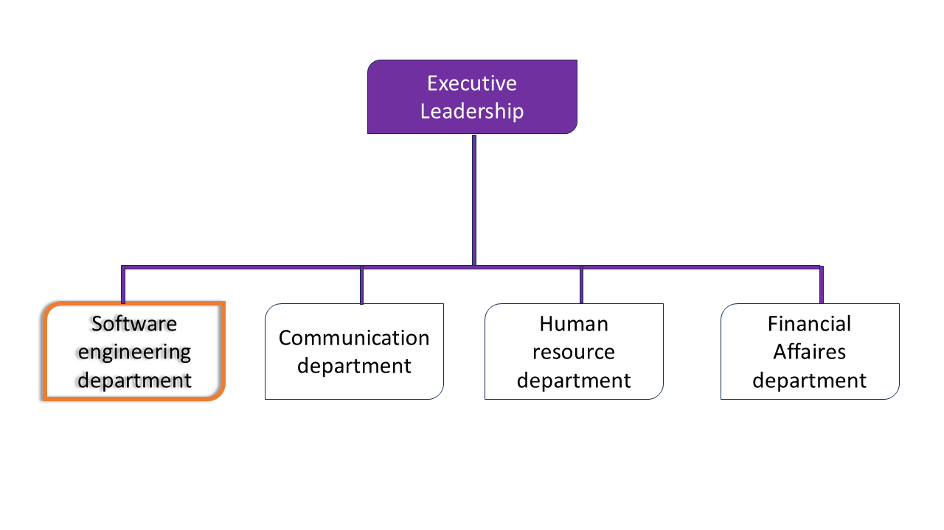
Figure 1Functional Organization of Shaderl

Figure 1: Functional Organization of Shaderl

IV- GEOGRAPHICAL LOCATION
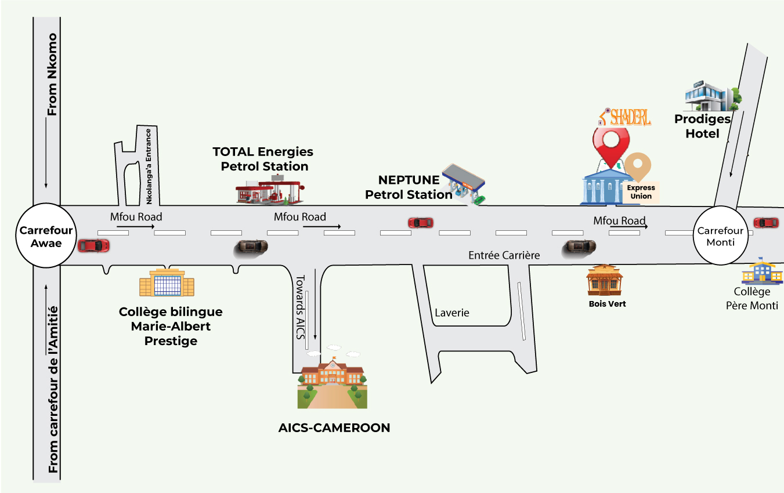
Coming from Awae junction, the location of Shaderl is facilitated by the map below.
Figure 2: Geolocation plan of Shaderl

V- BRIEF PRESENTATION OF THE PROJECT THEME
Following our arrival at Shaderl, we were encouraged to suggest practical and innovative project ideas that reflect real-world problems faced by Cameroonians. After analyzing our environment, we proposed the theme: "DESIGN AND IMPLEMENTATION OF A REAL ESTATE PLATFORM”. This system will be made up an admin who manages user accounts, a property owner which will oversee managing property listings. A public-facing interface where users can browse property announcements, search based on filters, a login system to access more detailed property data and integrated messaging to contact the property owner directly. The platform aims to centralizes listings, supports search, filters, enables direct owner contact, and integrates payment functionality for simple, local subscription payments.

CONCLUSION
The insertion phase marked our integration into the professional setting of SHADERL. Over two weeks, we familiarized ourselves with the company structure, resources, team dynamics, and collaborative spirit. This environment put in place all the necessary equipment for hard work and collaboration. We met other interns with who we were doing collaborative works and finally, we chose our theme “DESIGN AND IMPLEMENTATION OF A REAL ESTATE PLATFORM”.

PART TWO

EXISTING SYSTEM

Preamble

The existing system is a document that provides a view of how the current system works, how it carries out different activities, it equally provides a deep understanding of the system associated to the various limitations and the problems that result from it and we propose the solution.
Content overview

INTRODUCTION
- PRESENTATION OF THE PROJECT THEME
- STUDY OF THE EXISTING SYSTEM
- CRITICISMS OF THE EXISTING SYSTEM
- PROBLEMATICS
- PROPOSED SOLUTION
CONCLUSION

INTRODUCTION
In developing a software solution for any given domain, it is essential to understand the existing systems and the challenges users face. In the Cameroonian real estate landscape, current practices are outdated and largely informal. Most users struggle with unreliable sources, poor visibility, and high risks of fraud. A thorough critique of the current system helps us define the shortcomings and sets the groundwork for designing a modern, efficient solution.

PRESENTATION OF THE PROJECT THEME
The real estate sector in Cameroon is marked by informal, fragmented, and often inefficient property search processes. Many people still rely on neighborhood agents, handwritten posters, or unstructured social media posts to find housing methods that lack security, accuracy, and professionalism. This often results in wasted time, misinformation, and financial loss for property seekers. To address these challenges, we proposed the theme: "DESIGN AND IMPLEMENTATION OF A REAL ESTATE PLATFORM."
This platform aims to:
- Centralize real estate listings on a single, structured digital platform.
- Provide property search and filtering, making it easier for users to find houses that match their needs.
- Facilitate secure and direct communication between property owners and seekers without intermediaries.
- Eliminate the need for upfront visit fees, by offering enough detail and transparency before physical visits.
The goal is to simplify access to reliable property information, reduce time and cost burdens on tenants, and build trust in the property search process across Cameroon.

STUDY OF THE EXISTING SYSTEM
Current real estate practices in Cameroon pose significant inconveniences:
- Unverified and Fragmented Listings: Properties are primarily advertised on informal channels like WhatsApp groups, Facebook pages, or handwritten signs posted on walls and trees. There is no centralized, trusted database. This forces seekers to spend excessive time and mobile data contacting numerous agents or owners, often to find that the property is already rented, the price was misrepresented, or the contact is fake.

Figure 3: Where Cameroonians find property listings (source: surveys)
- Fraud and Financial Exploitation: A common and frustrating practice is the demand for non-refundable "viewing fees" or "agency fees" before a visit is even scheduled. Seekers often pay these fees only to find the property doesn't match the description, is unavailable, or worse, doesn't exist. This preys on the desperation of those needing housing.
- Manual and Opaque Transactions: The process remains heavily reliant on paper-based agreements and cash payments. This lack of digital records leads to disputes over agreements, lost receipts, and no paper trail for accountability, making it difficult to resolve conflicts.

- Inefficient and Physical Demanding Search: Without a centralized platform, searching for a property involves physically scouting neighborhoods (which is time-consuming and costly in transportation) or relying on word-of-mouth, which severely limits options. There are no efficient tools to filter for specific needs like a specific neighborhood in Yaoundé, a price range, or essential features like running water or a secure compound.
- Complete Lack of Trust Mechanism: There is no way for a seeker to know if an agent or landlord is reputable. One cannot check if a property has a history of issues like unresolved maintenance disputes, fraudulent landlords, or frequent tenant turnover. Transactions are based on blind trust, which is frequently broken.

CRITICISMS OF THE EXISTING SYSTEM
Table 1: Criticisms of the existing system
LIMITATIONS | CONSEQUENCES | PROPOSED SOLUTIONS
1. Unverified and Fragmented Listings. Listings are scattered across informal channels (WhatsApp, Facebook, physical signs) with no central source of truth. | • Wasted time, effort, and mobile data for seekers.  • Discovery of outdated, mispriced, or already-rented properties.  • High risk of encountering fake contacts or scams. | A centralized, verified platform: Develop a single web-based portal that aggregates and validates listings from all sources (agents, owners, agencies) into a unified, searchable database.
2. Fraudulent Financial Practices. The widespread demand for non-refundable "viewing fees" prior to a property visit. | • Direct financial loss and exploitation of desperate seekers.  • Payment for properties that are misrepresented, unavailable, or non-existent. | A strict no upfront fees policy prohibiting charges for viewing or accessing listing information.
3. Subjective and Discriminatory Pricing  Prices are set manually without market reference, often leading to bias and discrimination. | • Unfair and inflated pricing for certain seekers.  • Lack of transparency in how rental or sale values are determined.  • Market inefficiency and inequality. | Dynamic pricing tool: Incorporate a feature that suggests fair market-driven price ranges based on objective data like location, property features, amenities, and current market demand.
4. Inefficient Search Process. The search process is manual, requiring physical neighborhood scouting or unreliable word-of-mouth. | • Significant expenditure of time and transportation costs.  • Limited options that do not meet specific needs (location, price, amenities). | Advanced filtering and search tools: Implement intuitive filters for location (e.g., specific neighborhoods in Yaoundé), price range, number of rooms.

PROBLEMATIC
“How can we create a centralized, transparent, and trustworthy digital platform that eliminates the fraud of upfront fees, reduces the inefficiency of fragmented searches, and empowers Cameroonians to find housing safely and efficiently?”

PROPOSED SOLUTION
To solve the above challenges, we propose a platform with:
- Centralized and Verified Listings: A single, searchable database of property listings. Each listing is manually reviewed and verified by a platform administrator to ensure authenticity before it goes live, drastically reducing fake posts.
- Secure User Profiles: Account-based access for owners, agents, and seekers. This ensures that every user is identifiable, adding a layer of accountability to all interactions on the platform.
- Advanced Filtering Tools: Users can efficiently search for properties using specific filters such as location (city, neighborhood), price range, number of bedrooms, property type (house, apartment, land), and key features.
- Integrated Messaging System: A built-in chat function allows seekers to contact property owners or agents directly through the platform without sharing personal phone numbers initially. This keeps communication organized and recorded.
- No Visit Fees: No need for pre-payment before viewing a house physically.
- Review and Rating System: A trust-building mechanism where users can leave feedback on their experience with a property, landlord, or agent, creating a community of verified and reliable actors.

CONCLUSION
After a detailed study of the existing real estate mechanisms in Cameroon, it is evident that the system suffers from informal networks, and lack of transparency fuels inefficiency and lack of trust. Our proposed our solution which is DESIGN AND IMPLEMENTATION OF AN INTELLIGENT REAL ESTATE LISTING PLATFORM directly attacks these flaws. By replacing opaque, fragmented processes with a verified, transparent, and user-driven digital marketplace, we aim to restore confidence, save time and money for seekers, and introduce a much-needed layer of professionalism and security to the Cameroonian real estate experience.

PART THREE

THE SPECIFICATION BOOK

Preamble

The specification book is a document which is been established by the customer needing a particular product and the producer (engineer) who is to create the product, which is to be respected to its fullness during the realization of the product. From this, we obtain the major importance of the specification book.
Content overview

INTRODUCTION
- CONTEXT AND JUSTIFICATION
- OBJECTIVES OF THE PROJECT
- EXPRESSSION OF NEEDS
- PROJECT PLANNING
- ESTIMATED COST OF THE PROJECT
- PROJECT CONSTRAINTS
- LIST OF PARTICIPANTS AND DELIVERABLES
CONCLUSION

INTRODUCTION
The specification book of our report helps us to provide details about our theme, to improve our understanding of it and increase the likelihood of it succeeding. To delimitate the scope of our project, we will specify the context of our theme. From the context, we will list the problems we have identified in our context and that we have decided to address throughout the project. After presenting our solution, we will talk about the objective we have set for the project. Also, we will explore the needs to which our system will respond both at the functional and non-functional level. We will then look at the estimated financial requirements for our project and establish a plan we will follow to complete our project on time. From here we will discuss what is expected of us by the end of the project under the project deliverables.

I. CONTEXT AND JUSTIFICATION

A. CONTEXT
The Cameroonian real estate market is characterized by high demand but operates primarily through informal and fragmented channels. Property seekers including students, young professionals, and families rely heavily on word-of-mouth, unmoderated social media groups, physical signposts, and local agents. This reliance on decentralized information sources has created a market environment plagued by inefficiency, a significant lack of transparency, and high vulnerability to fraudulent practices. The absence of a centralized, digital infrastructure forces users into a manual, time-consuming, and often exploitative search process.

B. JUSTIFICATION
This project is justified by the critical need to solve key market failures:
- To Combat Financial Exploitation and Fraud: The prevalent practice of demanding non-refundable "viewing fees" before a property visit leads to direct financial losses for seekers. This platform will enforce a strict no-upfront-fee policy, protecting users from this exploitative tactic and building financial trust.
- To Centralize and Verify Information: The existing system's fragmentation across social media and physical posters results in wasted time, outdated listings, and misinformation. Our platform provides a single, trusted source where all listings are verified by administrators, save users significant time and effort.
- To Introduce Efficiency and Transparency: The manual process of physically scouting neighborhoods or relying on unreliable networks is inefficient and offers no price benchmarking or accountability mechanisms. This solution will modernize the search with advanced filters, integrated geolocation, and a user-review system, creating a transparent, efficient, and user-driven marketplace.
The platform addresses these urgent needs to build trust, reduce costs, and make the housing market more accessible and professional.

II. OBJECTIVES OF THE PROJECT

General Objective:
To design and implement a centralized real estate platform that brings trust, transparency, and efficiency to the Cameroonian property market by replacing informal, high-risk practices with a secure, user-friendly digital marketplace.

Specific Objectives:
Specifically, the platform will:
- Enable seamless registration and login for property seekers, owners, and agents, providing secure, role-specific dashboards to manage their activities.
- Provide detailed, verified property listings. Each listing will feature high-quality images, accurate descriptions, and clear location information, with all data being vetted by a platform administrator before publication.
- Implement advanced search and practical filters that reflect the local market, allowing users to find properties based on essential criteria like location, price, number of rooms, and key amenities (e.g., "furnished," "has backup generator,").
- Foster transparency and accountability by integrating a user review and rating system, allowing tenants and buyers to rate their experience with landlords and agents, thereby building a community-driven reputation system.
- Facilitate secure and direct communication through a built-in messaging system, enabling verified users to contact each other without sharing private contact details initially, reducing spam and potential fraud.
- Eliminate the practice of upfront viewing fees by establishing and enforcing a strict platform-wide policy against this exploitative tactic.

III. EXPRESSION OF NEEDS

Functional Needs
- User authentication system
- Secure registration and login functionality for both property seekers and owners.
- Role-based access control.
- Property Management Dashboard
- Create and edit property listings.
- Upload photos, set availability dates and pricing.
- View inquiry statistics and response metrics.
- Property Search and Discovery
- Advanced search functionality with filters for location, property type (apartment, house).
- Saved searches and favorite properties functionality.
- Communication System
- Secure in-platform messaging between users.
- Notification system for new messages and listing updates.
- Contact history tracking for accountability.
- Subscription & Payments
- Plans (e.g., Basic/Standard/Premium: number of listings, visibility).
- Payment via OM/MOMO (initiate, confirm, success/failure callback).
- Subscription status & history.

Non-Functional Needs
Non-functional requirements are a set of criteria that define the overall qualities, characteristics, and constraints of a software system, rather than its specific behaviors or functions. These requirements describe how the system should operate, rather than what it should do. Performance, Reliability and Security
- Performance defines how fast a software system responds to certain user’s action under certain workload. It explains how much a user must wait before the target operation.
- Reliability and Availability:
-The application should have high uptime and minimal downtime, ensuring users can access the platform consistently.
-The application should have a friendly user interface (UI) and should be easy to use.
-The code should be clear to facilitate future development and improvement.
- Security
The application should provide a strong security mechanism to reassure user’s that they can trust it for their sensitive information. Some of the security principles include confidentiality, Integrity and Authentication.

IV. PROJECT PLANNING
- Chronogram of activities
Table 2: Chronogram of activities
PHASE | OBJECTIVE | OUTPUT | DURATION | PERIOD
INSERTION | Collecting information from enterprise | Insertion Book | 2 weeks | 1st to 14th July 2025
EXISTING SYSTEM | Study of the existing system | Existing system | 1 week | 15th to 21st July 2025
SPECIFICATION BOOK | Specification of the user needs | Specification Book | 5 days | 22nd to 26th July 2025
ANALYSIS | Analysis | Capture of user needs, Use case and textual description Modelling | 2 weeks | 27th July to 9th August 2025
CONCEPTION | Hardware and software conception | Conception book | 2 weeks | 10th to 23rd August 2025
REALIZATION | Realization of the system | Realization Document | 3 weeks | 24th August to 13th September 2025
DEPLOYMENT | Deployment of the system | Testing and debugging the software | 2 weeks | 14th to 27th September 2025
WRITING USER GUIDE | Instruction on how to use the software and hardware | User Guide | 3 days | 28th to 30th September 2025

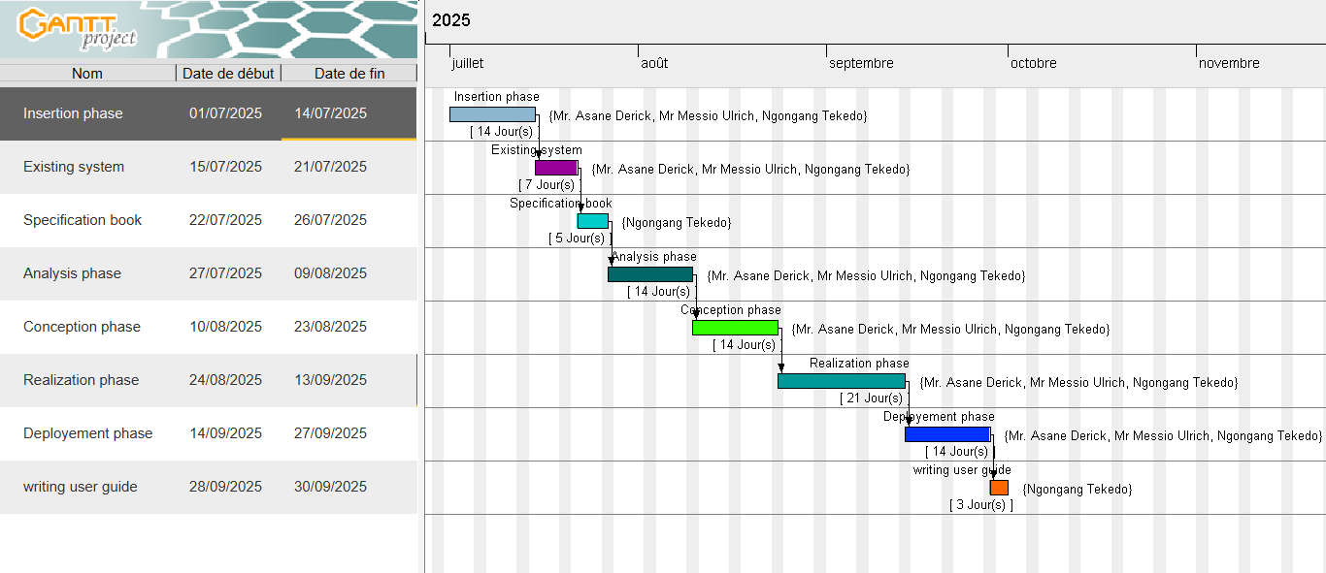
- Gantt Project Planning
Figure 4: Project planning

V. ESTIMATED COST OF THE PROJECT
a. Software Resources
Table 3: Software Resources (Source: https://www.g2.com/categories/pricing)
RESOURCES | DESIGNATION | USAGE | QUANTITY | UNIT COST(FCFA)
Text Editor | Microsoft Office word 2019 | For typing and formatting of report | 1 | 161000
Cloud Storage | GitHub | Saving report and source code | 1 | Open source
Web browser | Google chrome | For research and viewing the application | 1 | Freeware
Operating system | windows 11 pro | Computer operating system | 1 | 106350
Presentation | Microsoft Office PowerPoint 2019 | For making presentation | 1 | 84230
Development tool | Visual studio code | Code editing | 1 | Freeware
Geo-location plan designing tool | EdrawMax | To draw Location plan | 1 | Free version
Modelling tool | Visual paradigm CE | For drawing UML diagrams | 1 | Free version
Project planner | Gantt Project | For building Gantt Chart | 1 | Free software
Database management system | MySql | Communicating with the database | 1 | Open source
TOTAL 1 |  |  |  | 351,580

b. Hardware Resources
Table 4: Hardware Resources (sources: Mercurial-2025)
RESOURCES | HARDWARE | USAGE | QUANTITY | UNIT COST(FCFA)
Laptop | (HP) Intel® CoreTM Ultra 7 155U @1.70GHz | Main resource for the accomplishment of this project; report writing, designs, analysis, coding | 1 | 259,900
Printer | HP LASERJET PRO COLOR M102W | For printing the report | 1 | 172083
Modem | MODEM WIFI 3G MOBILE TP LINK M5250 | For network connectivity | 1 | 19900
USB key | SANDISK 8GB 2.0 CRUZER BLADE | Storage Medium | 1 | 4534
Ream of papers | INACOPIA A4 500 PAPER 5 REAMS | Print hard Copy | 1 | 31620
TOTAL 2 |  |  |  | 488,846

- Human Resources
Table 5: Human Resources (Source: https://www.paylab.com)
RESOURCES | NUMBER OF DAYS | NUMBER | COST PER DAY (IN FCFA) | TOTAL COST (IN FCFA)
Project Manager | 60 | 1 | 250000 | 15,000,000
Analyst | 30 | 1 | 150000 | 4,500,000
Designer | 25 | 1 | 130000 | 3,250,000
Programmer | 32 | 1 | 100000 | 3,200,000
TOTAL 3 |  | 4 |  | 25,950,000

- Global Estimation
Table 6: Global Estimation
TOTAL 1 (IN FCFA) | TOTAL 2 (IN FCFA) | TOTAL 3 (IN FCFA) | OVERALL TOTAL (IN FCFA)
351,580 | 488,846 | 25,950,000 | 26,790,426
Margin of error: 10% of Overall total
=2,679,042.6 FCFA
Final Total = Overall Total + margin of Error
=29,469,468.6 FCFA

VI. CONSTRAINTS
- Technical constraint
For the development of our system, we have sufficient robust tools to guarantee a minimum of security, extensibility and excellent scalability. Moreover, the programming phase will have to follow all the technical standards for a better performance in a reduced execution time, this is why the choice of the development technologies is crucial.
- Time constraint
The project will be realized in 13 weeks (3 months) starting from the beginning date, 1st July 2025.
- Cost constraint
The project will have a minimum cost of seven million which the developer(student) may not afford to.
- Integration constraints
Limitations imposed by third-party APIs or services that may have usage restrictions or performance issues.

VII. LIST OF PARTICIPANTS AND DELIVERABLES
A. LIST OF PARTICIPANTS
Table 7: List of participants
NAME | FUNCTION | ROLE
Mr. ASANE Derick | CEO of Shaderl | Professional supervisor at Shaderl
Mr. MESSIO Ulrich | Lecturer at AICS-Cameroon, Software Engineer | Academic supervisor
NGONGANG TEKEDO  Landry | Intern at Shaderl | Student at AICS-Cameroon

B. DELIVERABLES
In project management, any component materializing the result of a realization service is called a deliverable. In this case of our project, the deliverables are: A report composed of the following document
- The application
- The installation and user guide
- The PowerPoint

CONCLUSION
Reaching the end of this part, the list of objectives to be achieved has been enumerated and made clear. The specification book permitted us to present the different actors associated with the project as well as the requirement and provisional planning needed for the achievement of our project. We will move directly to the next part which is the analysis phase. In the analysis phase, we will model our system with a modelling language and a unified process, do a comparative study of uml and merise.

PART FOUR

ANALYSIS PHASE

Preamble

The main objective of the analysis phase is to capture the user’s need, the delimitation of the field of study and to have a clear understanding of the system in study. To achieve this, we will use UML (Unified Modelling Language) with the 2TUP (Two Track Unified Process) as method applied to UML to analyze the system. We will start by doing a comparison between UML and MERISE, of various unified processes and lastly, we will present the modelling of the solution we propose (our software).
Content overview

INTRODUCTION
I. METHODOLOGY
1. Comparative Study of UMl and Merise
2. Comparative Study of Unified Processes
3. Justification of the Method of Analysis
II. MODELLING OF THE SYSTEM
CONCLUSION

INTRODUCTION
System development can be thought of as having two major components: System analysis and system design which both help in understanding the details of the existing system or the system to be designed. The analysis and design of information systems has most of the time vocation to allow the creation of databases, which must represent as closely as possible the reality of the field studied thus requiring the use of a design method. This is why our choice will be directed on the UML method as it offers much to developers seeking a user-centered approach and/or a wide scope in design. This part of the report consists of the comparative study of UML and MERISE, unified processes and finally the various diagrams that meet the functional need requirements.

I. METHODOLOGY
1. COMPARATIVE STUDY OF UML AND MERISE
a. MERISE
MERISE stands for “Méthode d’Etude et de Réalisation Informatique pour des Systèmes d’Entreprise”. Although it is prescriptive to some extent, MERISE permits the participation of end users and senior management as well as data processing professionals in its decision cycle. MERISE is a method for designing, developing and carrying out IT projects. The goal of this method is to achieve the design of an information system. The MERISE method is based on the separation of data and processing to be carried out in several conceptual and physical models. The essentials of the approach lie in its three cycles: the decision cycle, the life cycle and the abstraction cycle, which cover data and process elements equally. The separation of data and processing ensures longevity in model. Indeed, the arrangement of data does not have to be often overhauled, while treatments are more frequently.
b. UML
UML (Unified Modelling Language) is a standard notation for the modelling of real-world objects as a first step in developing an object-oriented design methodology. Its notation is derived from three object-oriented design and analysis methodologies: Grady Booch's methodology for describing a set of objects and their relationships, James Rumbaugh's Object-Modelling Technique (OMT), Ivar Jacobson's approach which includes a use case methodology. Other ideas also contributed to UML, which was the result of a work effort by Booch, Rumbaugh, Jacobson, and others to combine their ideas, working under the sponsorship of Rational Software. UML captures information about the static and dynamic view of a system. UML 2.5 comprises of 14 diagrams which represent the different views of a system. The 14 diagrams can be subdivided into two, Static or structural and Dynamic diagrams. These diagrams include;

i. STATIC OR STRUCTURAL DIAGRAMS
Structural diagrams represent the static components of a system; they emphasize on what should be in the system we are modelling. They include:
- Class diagram;
- Object diagram;
- Component diagram;
- Deployment diagram;
- Composite structure diagram;
- Package diagram;
- Profile diagram;
ii. BEHAVIORAL OR DYNAMIC DIAGRAMS
The behavioral diagrams capture the dynamic state of a system; they emphasize on what should happen in the system we are modelling. They are:
- Use Case diagram;
- Activity diagram;
- State Machine diagram;
- Sequence diagram;
- Communication diagram;
- Interaction diagram;
- Timing diagram;

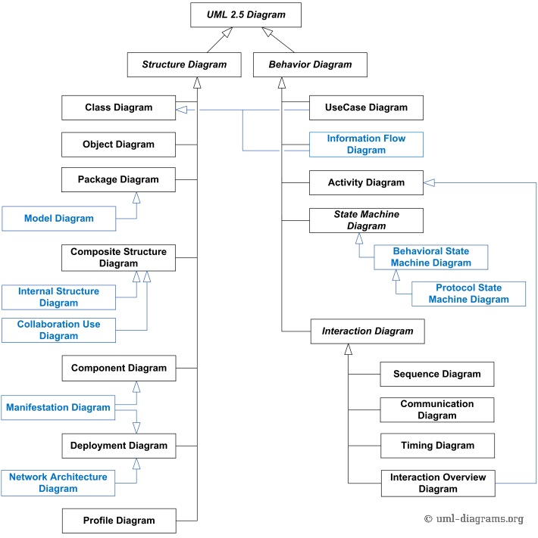
Figure 5: UML 2.5 overview (source: uml-diagram.org )

Table 8: Difference between uml and Merise
MERISE | UML
It stands for Méthode d’Etude et de Réalisation Informatique pour des Systèmes d’Entreprise | Unified Modelling Language
MERISE is a systemic method of analysis and design of information systems. That is, it uses a system’s approach. | UML is however not a method but rather an object modeling language to which it is necessary to associate an approach to make it a method. This is the case with the 2TUP method; RUP and XP.
MERISE proposes to consider the real system from two points of view:  - A static view (data)  - A dynamic view (treatments). That is, with the MERISE method, we have a separate study of the data and the treatments. | UML offers a different approach from that of MERISE in that it combines data and processing. Because with UML, centralizing the data of a type and the associated processing makes it possible to limit the maintenance points in the code and facilitates access to information in the event of software development. In addition, UML describes the dynamics of the information system as a set of operations attached to the objects of the system.
Rational | Object

2. COMPARATIVE STUDY OF UNIFIED PROCESSES
a. A Unified Process
A Unified Process is a process of development of software constructed on UML; it is iterative, incremental, centered on architecture, driven by use cases requirements.
Iteration is distinct sequence of activities with a basic plan and evaluation criterion that produces an internal or external output. Either the content of an iteration is improved, or the evolution of the system is evaluated by users.
An increment is the difference between two released products at the end of two iterations. Each iteration that the group is capable of integrating the technical environment in order to develop a final product and give users the possibility of having tangible results.
Centered on architecture the different modules derived during the establishment of our system must be reliable and coherent.
Driven by use case and requirements enables the clear definition of a user’s needs and priorities respectively thereby minimizing the risk of project failure.

b. The Two Track Unified Process
2TUP is a unified process which is built on UML and has as objective to bring solution to constraints of functional and technical changes imposed on information systems by strengthening controls on development capacities. It proposes a Y-sharped development life cycle that separates the functional aspect from the technical aspects, and the merging of these two forms the implementation aspect. 2TUP distinguishes therefore two branches: the functional and technical branches, the combination of the result of these two branches forms the third: the realization branch – where we realize our system. The diagram below illustrates the branches of 2TUP.

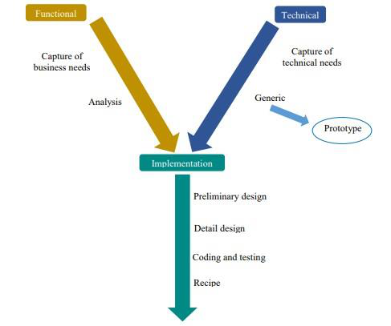
Figure 6: 2TUP Diagram

The left branch (functional branch)
It captures the functional needs of a system. This ensures the production of software that meets the needs/requirements of the user. The analysis here consists of studying precisely the functional specification in order to obtain an idea of what the system is going to realize, and its result does not depend on any technology.

The right branch (Technical branch)
The technical branch enumerates the technical needs and proposes a generic design validated by a prototype. The technical needs include constraints and choices related to the conception of the system, the tools.

The middle branch (Realization or Implementation branch)
In this branch, we study the preliminary conception, detailed conception, and documentation of the system. The realization branch supports the following: Preliminary conception: This is the most sensitive step of 2TUP as it is the confluence of the functional and technical branch. It is completed when the deployment model, the operating model, the logical model, interphases and the software configuration model are defined. We have the following diagrams:
- Component Diagram;
- Deployment Diagram;
- Package Diagram;
- Composite Structure Diagram;
Detailed conception: This is the detailed design of each feature of the system. We have the following diagrams:
- Class;
- Sequence;
- Object;
- Timing diagram;
Coding and testing: This is the phase where we program the designed features and test the coded features.
The recipe: Also known as the deliverables is the validation phase of the functions of the developed system.

3. JUSTIFICATION OF THE METHOD OF ANALYSIS
As method of analysis, we chose the Unified Modeling Language associated with the 2TUP software development process / method. This choice was made as a result of the following criterias;
UML is the current standard for programming in an object-oriented language. For this reason, it is widely understood and well known making it easy for a new programmer to join the project and be productive from the very first day.
UML diagrams allow teams to virtualize how a project is or will be working, and they can be used in any field, not just software engineering. The diagrams will allow teams to virtualize together how a system or a process will work or did work. It can provide new ideas for how teams have to collaborate to achieve the goal of the workflow process.
2TUP is centered around the creation and maintenance of a model, rather than the production of mountain documents.
2TUP is user oriented as it permits the development of software that responds to the needs of the users through the study of the user needs.
2TUP is iterative and incremental; hence it enables the project team to produce refined amelioration if necessary and easily integrate it in the already existing system.
2TUP by permitting the project team identify and test the key functionalities of the system limits the risk related to building the system

II. MODELLING OF THE SYSTEM
1. Use Case Diagram
a) Definition
A use case diagram describes the high-level functions and scope of a system. A use case is a specification of behavior. The main objectives of the use case diagram are:
- Provide a high-level view of the system.
- Identify the functions of the system.
Use case diagrams are complemented by textual descriptions of each use case, providing greater detail and clarity about their functionalities and interactions.
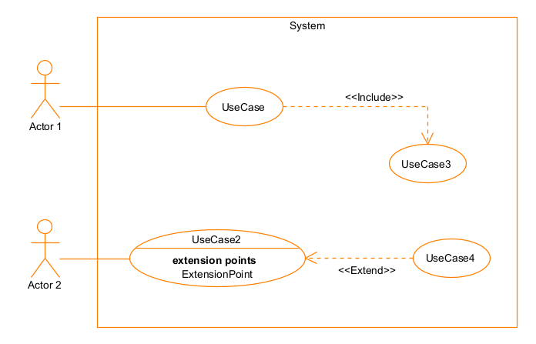
b) Formalism
Figure 7: Use Case Diagram Formalism

Table 9: Use Case Diagram Components
Elements | Notation | Description
Actor | 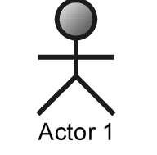 | Represents an entity that directly interacts with the system. The actor is what performs the different possible actions of the  System.
Use case | 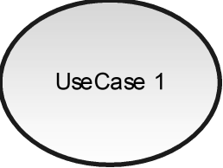 | A use case represents a functionality of the system. It is an action that can be performed by an actor.
Association | 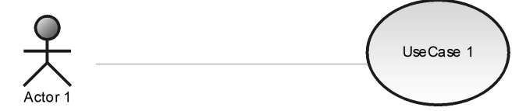 | It indicates that an actor takes part in a use Case.
Include | 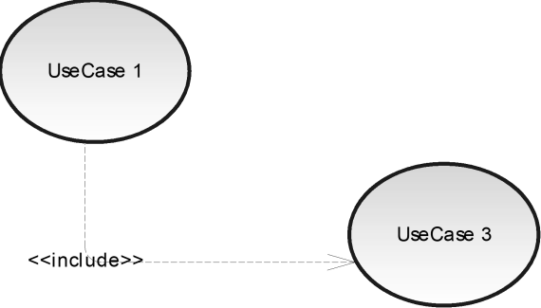 | An inclusion denotes that an included action must be performed before the including action can be performed.
Extend | 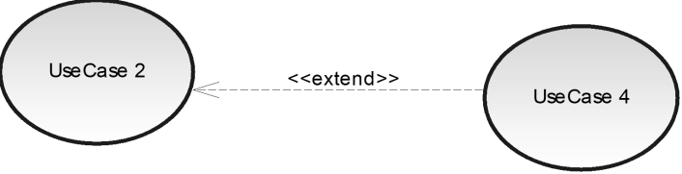 | An extension denotes that an extending action may be performed while an extended action is being  performed.
Generalization | 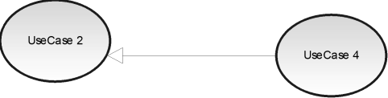   | This shows that an actor or a use case is a kind of another abstract or concrete actors can be defined and later specialized using generalization relationship.
System | 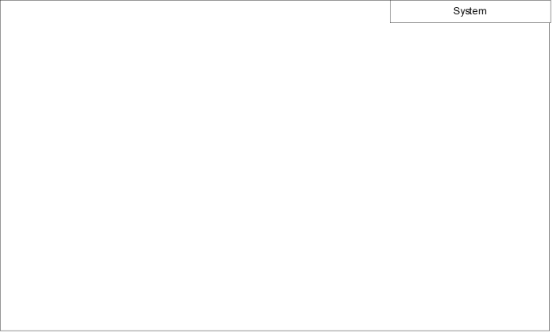 | It is a container of use cases which interact with external actors.

c) The Actor of our System
Table 10: Actors of our System
Actors | Role
Visitor | Register
Customer | Search property  Edit profile  View notification  Consult messages
Landlord/Agent | Manage property  Subscribe
Administrator | Manage User profile  Send notification
Geolocation API | Locate different properties
Payment API | Receive payment for the subscription

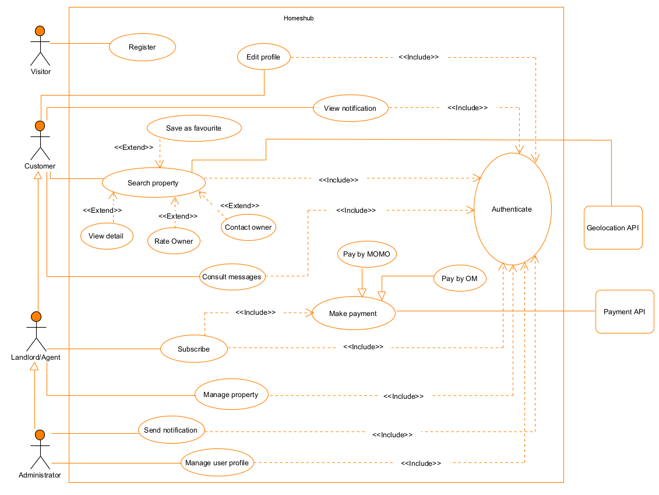
d) General Use Case Diagram
Figure 8: General Use Case Diagram

e) Manage property Use Case Diagram
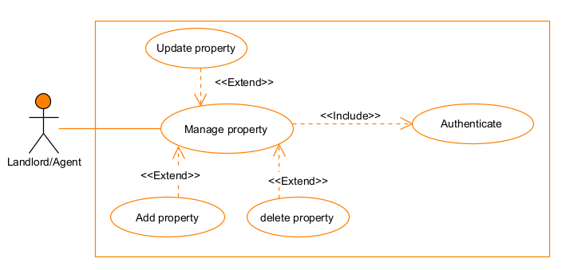
Figure 9: Manage property Use Case Diagram

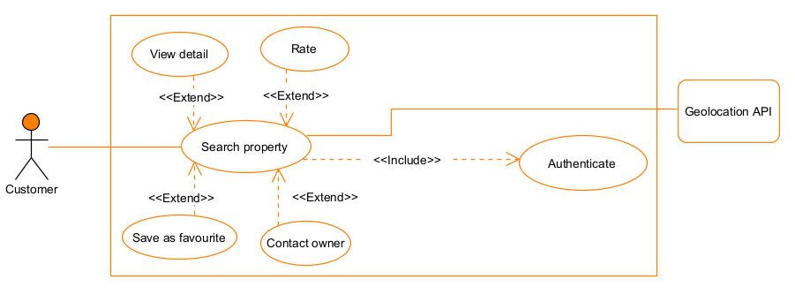
f) Search property Use Case Diagram
Figure 10: Search property Use Case Diagram

g) Textual Description of Use Cases
Identification of content
Title | Textual description of use case authenticate
Summary | To permit the users to gain permission according to account types in order to access some functionalities of the system by identifying them.
Actors | Administrator, Landlord/Agent, Customer
Date | 08/08/2025
Description of scenario
Pre-condition | The user has an account
Trigger | The user clicks on the login button
Nominal scenario | - The user enters the URL of the platform.  - The system displays the home page.  - The user clicks on the login button.  - The system displays the login form.  - The user fills and submit the form.  - The system verifies the conformity of the field.  - The system sends the data to the database.  - The DBMS executes the query and return the result of the query.  - The system displays a success message and gives permissions to the user.
Alternative scenario | 6.a. In step 6 of the nominal scenario, the user enters wrong credential.  6.b. The system displays an error message then return to step 4 of the nominal scenario.
Exception scenario | 5.a. There is a network failure when the user submits the form.  5.b. The system displays an error message and return to step 4.
Post condition of success | User log in successfully
Post condition of failure | User not granted access
Table 11: Textual Description of Use Case Authenticate

Identification of content
Title | Textual description of use case search property
Summary | To allow users to find available properties based on specific criteria by entering search parameters or using the integrated geolocation API to automatically detect nearby properties.
Actors | Customer, Landlord/Agent, Administrator, Geolocation API
Date | 14/08/2025
Description of scenario
Pre-condition | -The user is logged in  -Properties are already registered in the system’s database.
Trigger | The user enters search criteria or allows geolocation.
Nominal scenario | - The user enters the URL of the platform.  - The system displays the homepage.  - The user enters search criteria in the search bar  - The system request location permission.  - If geolocation is chosen, the system sends a get user location request to the geolocation API.  - The geolocation API detects the user’s current location and send results to the system.  - The system sends data to the database.  - The DBMS executes the query and return the result  - The system process results and displays matching properties on the page.
Alternative scenario | 5.a. The user denies location permission.  5.b. The system continues with manual criteria only.
Exception scenario | 4.a. Location permission is denied or geolocation API fails.  4.b. The system displays an error message and prompts the user to enter a location manually.
Post condition of success | The user views a list of matching properties with details and map location.
Post condition of failure | No results are found, or location detection fails.
Table 12: Textual Description of Use Case Search property

Identification of content
Title | Textual description of use case subscribe
Summary | To allow users to find available properties based on specific criteria by entering search parameters or using the integrated geolocation API to automatically detect nearby properties.
Actors | Landlord/Agent, Payment API
Date | 14/08/2025
Description of scenario
Pre-condition | -The Landlord /Agent has an active account in the platform.  -Subscription plans are defined in the system.
Trigger | The Landlord/Agent scrolls down the homepage and clicks on “choose plan” for a selected subscription option.
Nominal scenario | - The Landlord/Agent logs in and accesses the homepage.  - The system displays the available subscription plans.  - The Landlord/Agent clicks on “Choose plan” for the desired subscription.  - The system redirects to the payment method selection page.  - The Landlord/Agent selects a payment option.  - The system displays the payment form with required details.  - The Landlord/Agent enters the payment details and confirms.  - The payment API processes the transaction and sends a confirmation to the system.  - The system updates the subscription status and displays a success message.
Alternative scenario | 5.a. The Landlord/Agent changes the subscription plan before payment.  5.b. The system returns to plan selection.
Exception scenario | 8.a. Payment API timeout.  8.b. The system asks the user to try again later.
Post condition of success | The Landlord/Agent subscription is activated and features linked to the chosen plan become available.
Post condition of failure | Subscription remains inactive due to payment failure.
Table 13: Textual Description of Use Case Subscribe

2. Activity Diagram
a) Definition
An activity diagram is a graphical representation of workflows that show the steps needed in the realization of a process, showing the details from a start point to an end point through all decisions and actions that can possibly be performed. Activity diagrams are intended to model both the computational and organizational process. The flow can be sequential, branched or current. Below is an activity diagram formalism.
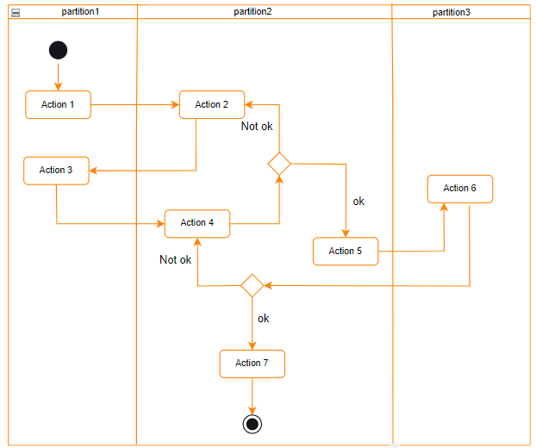
b) Formalism
Figure 11: Activity Diagram Formalism

Table 14: Activity Diagram Components
Elements | Notation | Description
Activity | 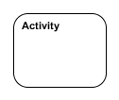 | Use to represent a set of actions.
Action | 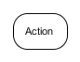 | Represent a task to be performed.
Control flow |  | A directed connection between two activity nodes through which tokens may flow.
Initial node |  | Shows the beginning of an activity or set of actions.
Final node |  | Stops all controls and object flows in an activity.
Decision node | 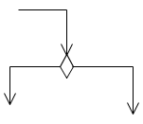 | Represents a test condition that slits an incoming activity edge into opposite outgoing activity edges.
Merge node | 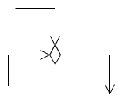 | Reunite different decision paths created using a decision node.
Partition | 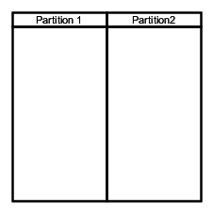 | A way of grouping activities performed by the same actor in an activity diagram or to group actions in the same thread.

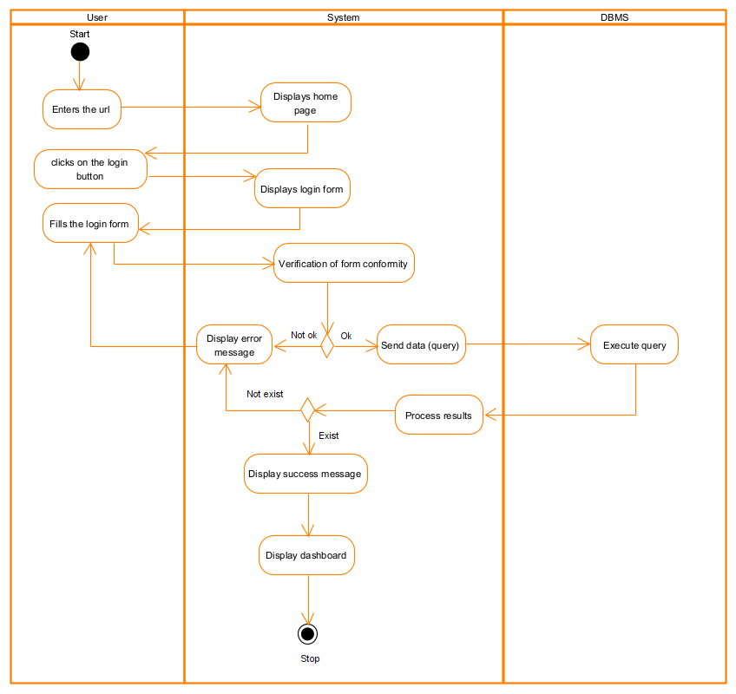
c) Authenticate Activity Diagram
Figure 12: Authenticate Activity Diagram

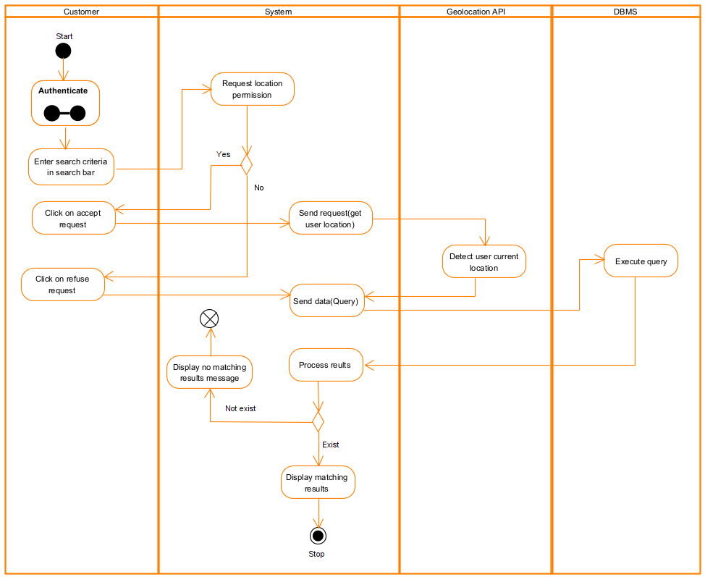
d) Search property Activity Diagram
Figure 13: Search property Activity Diagram

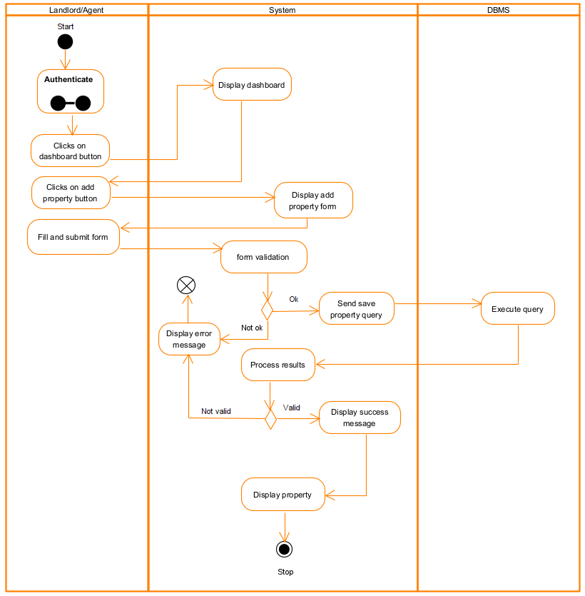
e) Add property Activity Diagram
Figure 14: Add property Activity Diagram

3. Sequence Diagram
a) Definition
A sequence diagram is a form of interaction diagram, which shows objects as lifelines running down the page and with their interactions over time represented as messages drawn as arrows from the source lifeline to the target lifeline. Sequence diagrams are good at showing, which objects communicate with which other objects and what messages trigger those communications. Sequence diagrams are not intended for showing complex procedural logic.
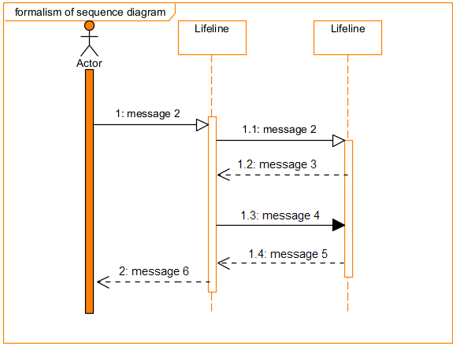
b) Formalism
Figure 15: Formalism of a Sequence Diagram

Table 15: Sequence Diagram Components
Elements | Notation | Description
Lifeline | 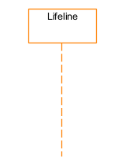 | It represents an individual participant in a sequence diagram, it is position at the top of the diagram.
Combined fragment | 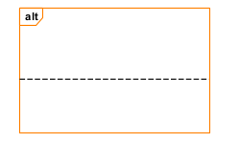 | It represents a choice of behavior in which at most one operand will be chosen.
Messages | 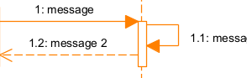 | These are arrows which represent direction of message flow. We have the synchronous, the asynchronous and the self-messages.
Activation |  | It describes the time period in which an operation is performed by an element.

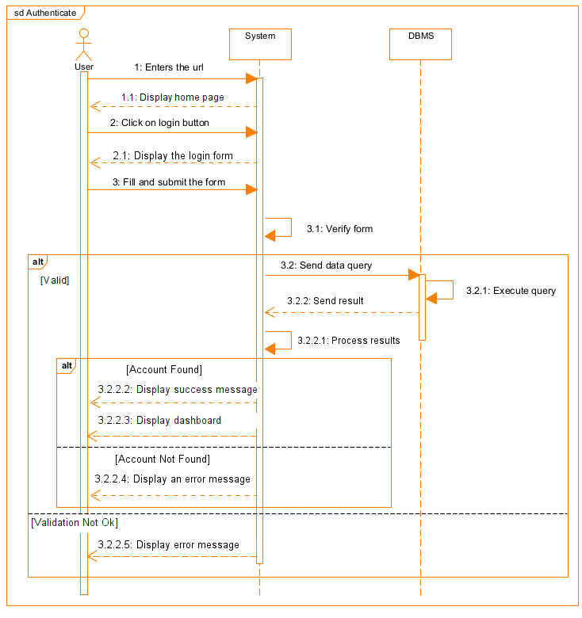
c) Authenticate Sequence Diagram

Figure 16: Authenticate Sequence Diagram

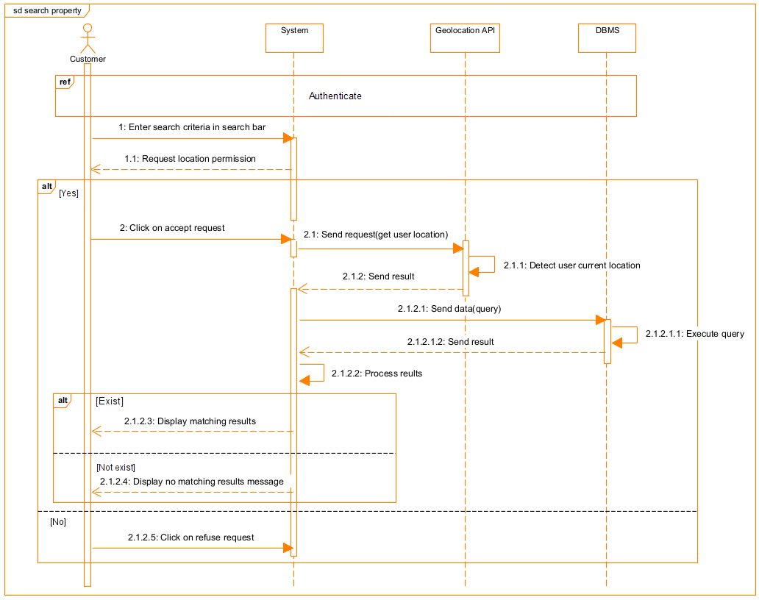
d) Search property Sequence Diagram
Figure 17: Search property Sequence Diagram

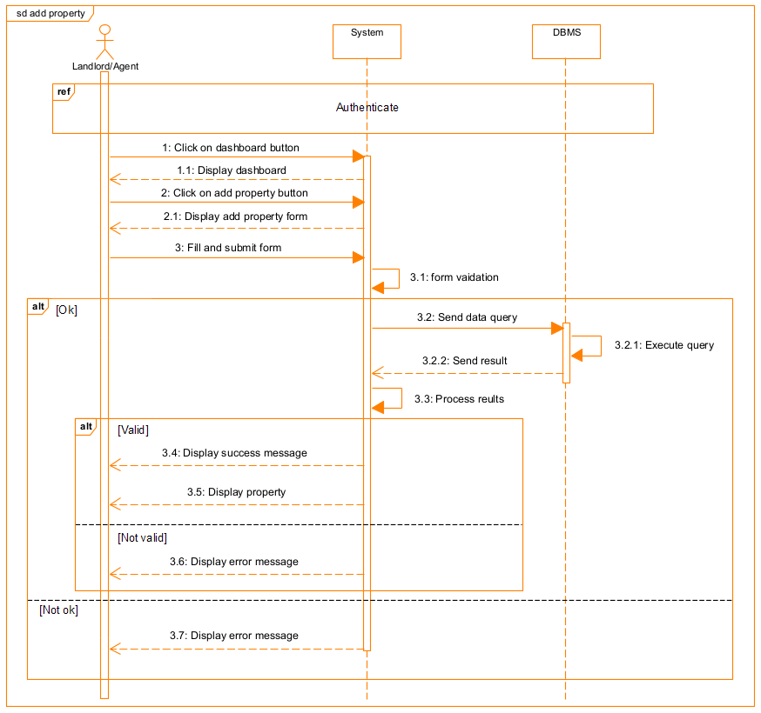
e) Add property Sequence Diagram
Figure 18: Add property Sequence Diagram

4. Communication Diagram
a) Definition
It is a diagram which is used to show the relationship between the actors of a system, both the sequence and the communication diagrams represent the same information but differently. Instead of showing the flow of message. It depicts the architecture of the object residing in the system as it is based on object-oriented programming.
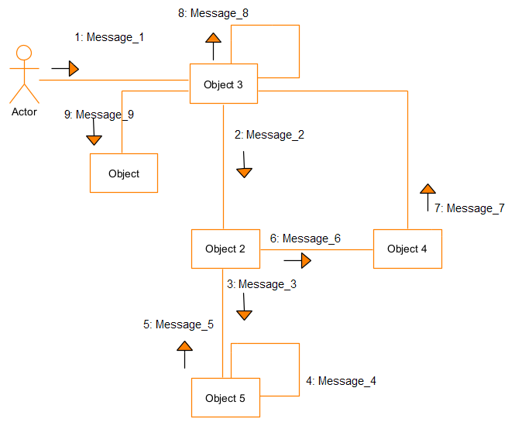
b) Formalism
Figure 19: Formalism of a Communication Diagram

Table 16: Communication Diagram Components
Elements | Notation | Description
Object | 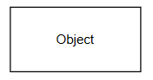 | An object represents an individual participant in the interaction conversion.
Link |  | It represents a choice of behavior in which at most one operand will be chosen.
Actor |  | A role plays by an entity that interacts with the subjects
Message | 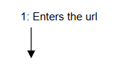 | It describes the time period in which an operation is performed by an element.

c) Authenticate Communication Diagram
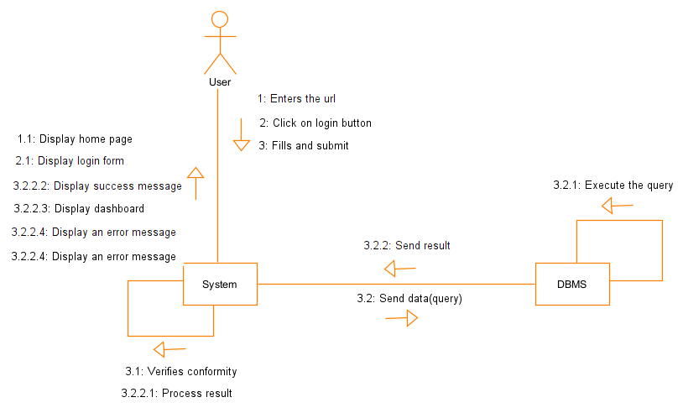
Figure 20: Authenticate Communication Diagram

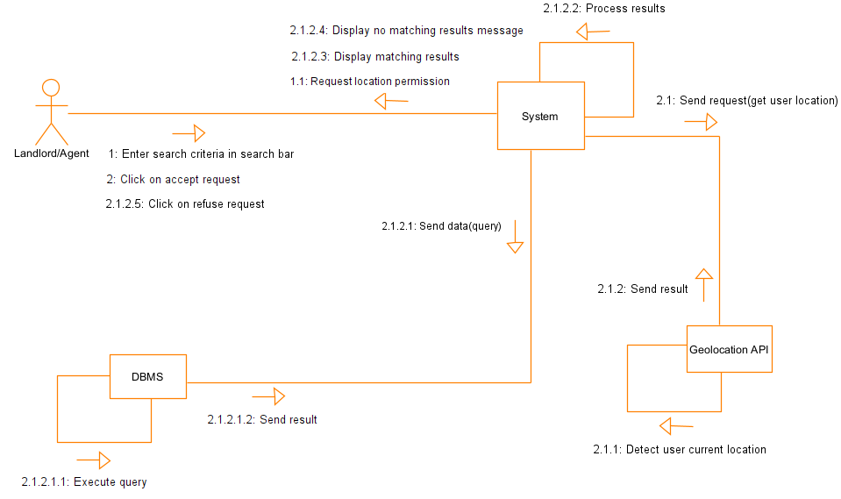
d) Search property Communication Diagram
Figure 21: Search property Communication Diagram

d) Add property Communication Diagram
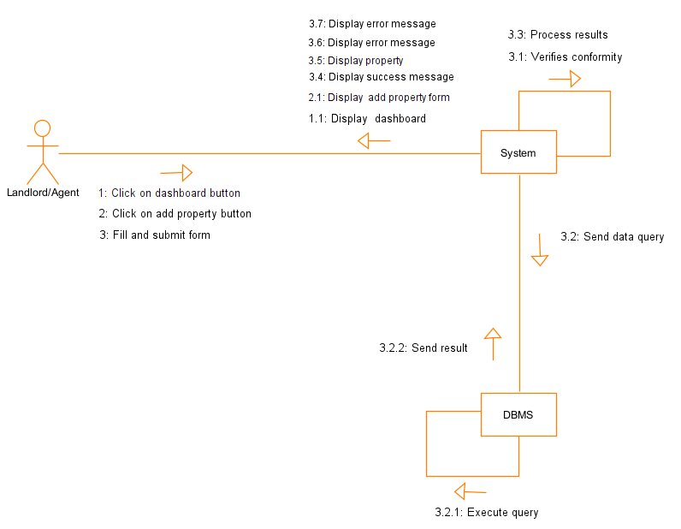
Figure 22: Add property Communication Diagram

CONCLUSION
In the analysis phase, we chose a software development process and modelling language, after which we presented the existing system, its limitation and our proposed solutions. We went forward explaining the functional need of our system, we saw the use case diagram which shows the relationship between the actors and use case (the action the actor can perform on the system), we saw the activity diagram which shows the workflow of our system, the sequence diagram and lastly the communication diagram. We will now move to the conception phase together with related diagrams.

PART FIVE

CONCEPTION PHASE

Preamble

The conception phase will permit us to present in an orderly manner the components necessary for the good functioning of our software, and also the architecture used for the proposed solution. It bridges the gap between the analysis phase and the realization phase.
Content overview

INTRODUCTION
- CLASS DIAGRAM
- STATE MACHINE DIAGRAM
- PACKAGE DIAGRAM
CONCLUSION

INTRODUCTION
The conceptual phase will describe in detail the necessary specifications, features and operations that will satisfy the functioning requirements of the proposed system as modelled in the analysis phase. This phase is meant to identify and consider essential components (hardware /or software), structure (network capabilities), processes and procedures for the system to accomplish it objectives. We will look at some diagrams such as the state machine diagram, package diagram, class diagram and the object diagram.

I. CLASS DIAGRAM
a) Definition
A class diagram is a static diagram that provides a visual representation of the static view of an application. It is used not only for visualizing and documenting various aspects of the system but also for constructing executable code. The class diagram describes the attributes, operations, and constraints of classes in the system. Its purpose is to model the static structure of an application.
b) Formalism
Figure 23: Formalism of a Class Diagram
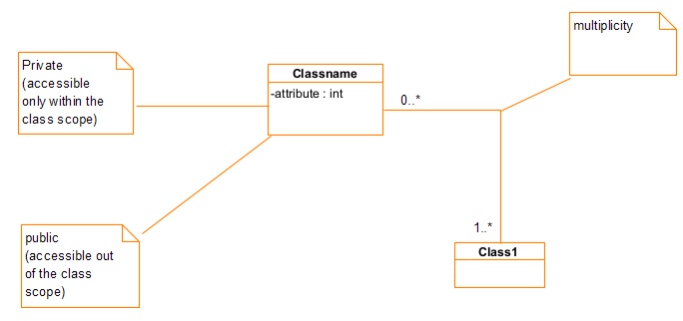

Table 17: Class Diagram Components
Elements | Notation | Description
Class | 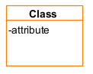 | A class is an element that defines the attributes and behaviors that an object is able to generate.
Composition | 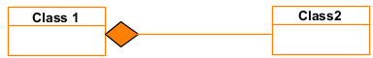 | If a parent of a composite is deleted, usually all of its parts are deleted with it.
Aggregation | 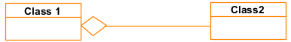 | If the parent of the aggregate is deleted, usually the children are not deleted
Dependency | 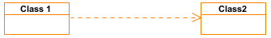 | It describes the time period in which an operation is performed by an element.
Generalization | 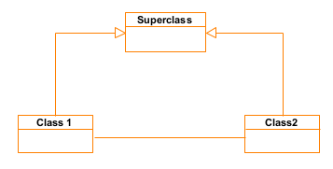 | It is a relationship between a whole thing (called superclass) and a more specific thing (called subclass).
Association | 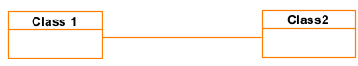 | It is a general type of relationship between elements, it may include cardinality, roles etc.

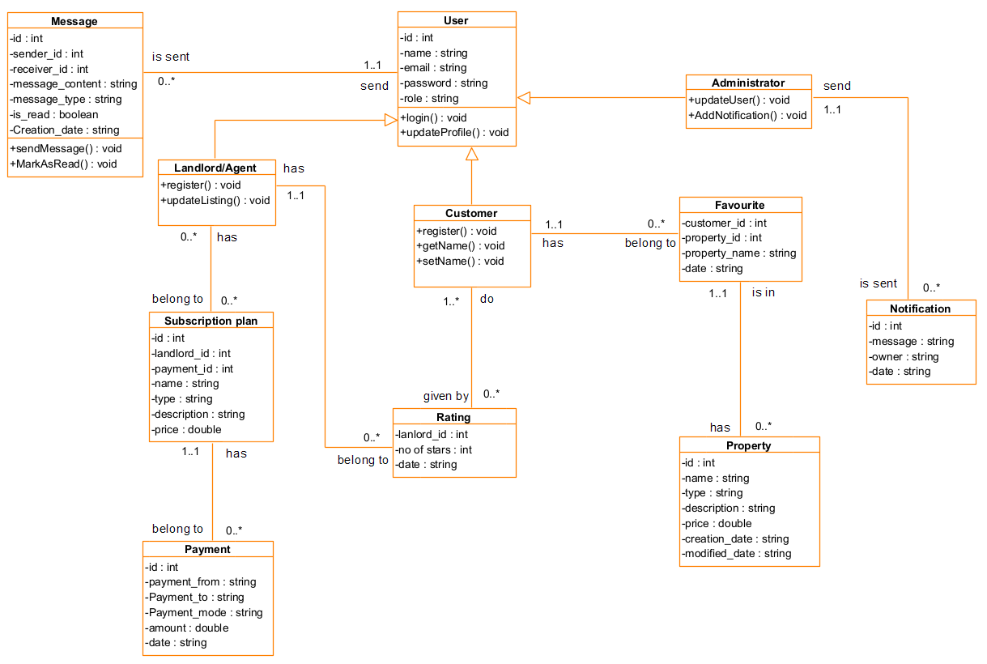
c) System Class Diagram
Figure 24: System Class Diagram

II. STATE MACHINE DIAGRAM
a) Definition
A state machine diagram describes the behavior of a single object in response to a series of events in a system. Also known as the state machine diagram, it models the dynamic flow of control from the state of a particular object within a system.
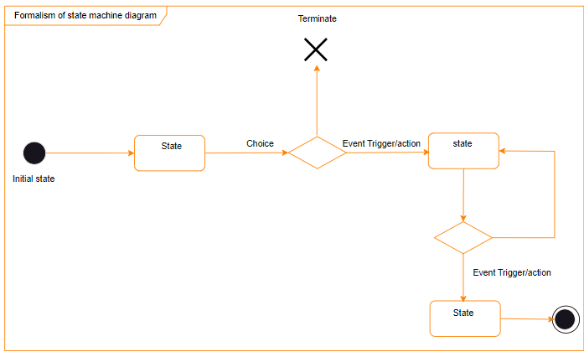
b) Formalism
Figure 25: State Machine Diagram Formalism

Table 18: State Machine Diagram Components
Elements | Notation | Description
State | 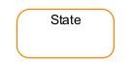 | Models a situation during which a certain invariant condition holds.
Initial State |  | It represents a default vertex, that is a source for a single transaction to the default or composite state.
Final State |  | A state specifying that the enclosing region is complete.
Transition | 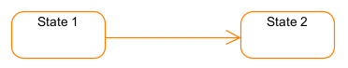 | A direction relation between a source and a target vertex.
Choice pseudo-State |  | A diamond symbol that indicates a dynamic condition with branched potential results.
Terminate |  | Implies that the execution of a state by means of its context is terminated.
Diagram Overview | 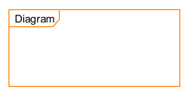 | A placeholder for the linked states in a state machine diagram.

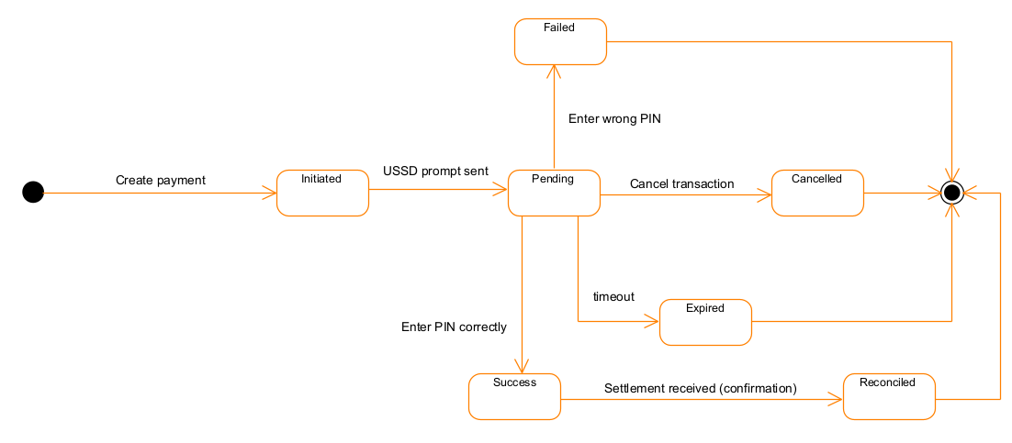
c) Payment State Machine Diagram
Figure 26: Payment State Machine Diagram

III. PACKAGE DIAGRAM
a) Definition
A package diagram is a structural diagram that depicts the organization and arrangement of various model elements in the form of packages. It provides a visual representation of how related UML elements, such as classes, diagrams, or even other packages, are grouped together.
b) Formalism
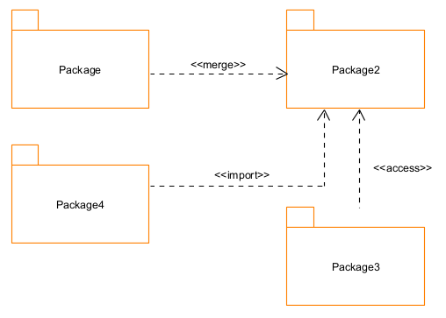
Figure 27: Formalism of a Package Diagram

Table 19: Package Diagram Components
Elements | Notation | Description
Package | 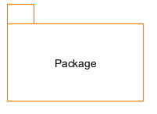 | A package is a namespace use to group related elements; it is a mechanism used to group elements into a better structure in a system.
Package import | 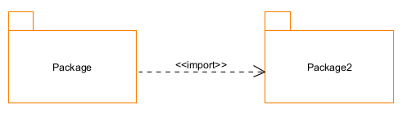 | A relationship which indicates that one functionality has been imported from one package to another.
Package access | 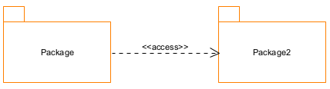 | A relationship indicates that one package requires assistance from the function of another package.
Package merge | 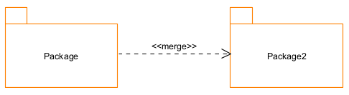 | It is a relationship which shows that the functionality of two packages are combined to a single function.

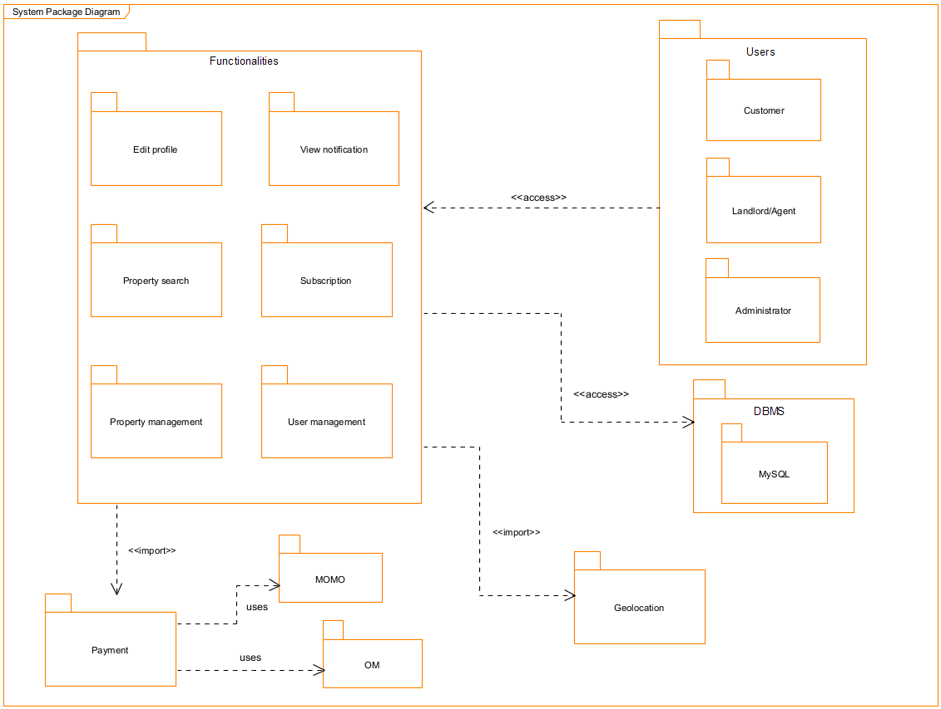
c) System Package Diagram
Figure 28: System Package Diagram

CONCLUSION
In the conception phase, we set the stage for a successful project through the creation of key diagrams such as class diagrams, state machine diagrams, and package diagrams. This phase facilitates a shared understanding among stakeholders, identifies and mitigates potential risks and issues, and establishes a robust architectural foundation for implementation. We finished this phase by looking at interaction between the various aspects and actors of our system. The next phase of our report is the realization phase where we will look at aspects concerning the implementation of our system.

PART SIX

REALIZATION PHASE

Preamble

In this phase we will to straight forward in the implementation of our solution, we will base ourselves on the analysis and conception phases, and also present the component and deployment diagrams.
Content overview

INTRODUCTION
I. ARCHITECTURE USE
- Physical Architecture
- Logical Architecture
II. DEPLOYMENT DIAGRAM
III. COMPONENT DIAGRAM
CONCLUSION

INTRODUCTION
In the realization phase, we will talk about the architecture we used, and some diagrams related to the physical aspect of the system like libraries, documents, as well as the physical topology of the components of the system when the software is been deployed.

I. ARCHITECTURE USE
- Physical Architecture
The design of the DBMS depends on its architecture. An n-tier architecture partitions on the whole system into related but separated n modules, which can be independently modified, altered, changed or replace. A large amount of data on web servers, personal computers (pc) and others are link with networks with the help of basic client or server architecture. Within the scope of our project, we made use of the n-tier architecture This architecture separates it tiers from each other based upon the user and the manipulated data in the database. Each layer has a well-defined communication interface, and the evolution of the layer is independent of the other. The n-tier of our system is made up of:
- The Presentation or Client Layer represents the different devices through which users interact with the real estate platform. These devices include mobile phones, laptops, and desktop computers used by customers, landlords, or administrators. Their role is to provide an interface for sending requests such as property searches, adding new property listings, or making payments, while also displaying responses such as search results, property details, and confirmation messages.
- The Application tier or Server acts as the central processing unit of the platform. It is responsible for handling all business logic, processing user requests, and coordinating interactions between the other servers. For instance, when a customer searches for a property, the application server processes the query, fetches the corresponding data from the database, and may also request location information from the geolocation server. It also manages user authentication, subscription validation, and payment requests.
- The Database Server (DBMS) is dedicated to storing and managing all data related to the platform. This includes user profiles, property listings, subscription plans, and communication records between customers and landlords. It ensures that the data is consistently updated, secured, and made available whenever needed by the application server. In this way, it guarantees the integrity and reliability of the information presented to users.
- The Geolocation Server provides location-based services that enhance the user’s search experience. By integrating geolocation APIs, it allows users to find properties based on their current position or within a defined geographic area. This server makes it possible to display results on a map, suggest nearby properties, and provide directions, thereby improving efficiency in property searches.
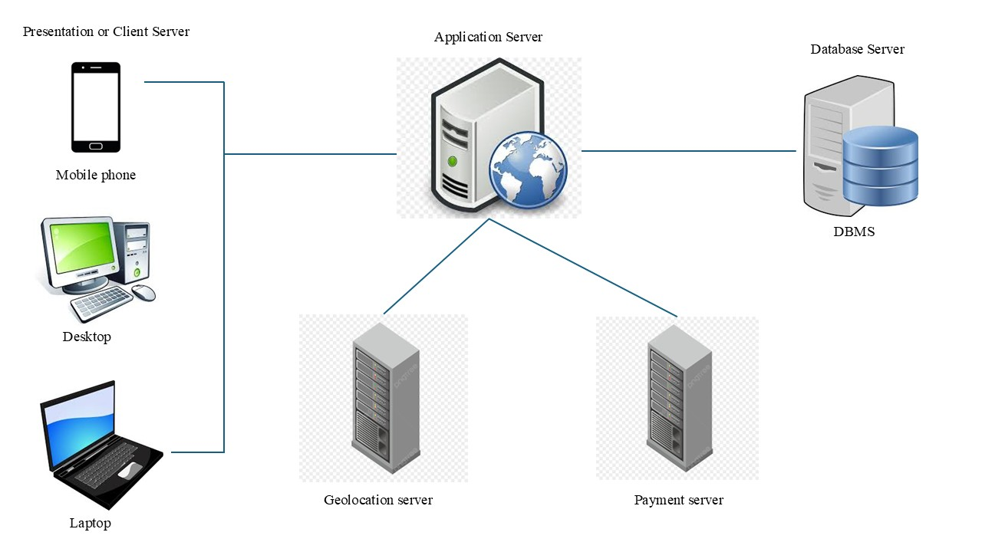
- The Payment Server manages all financial transactions within the platform. It is responsible for processing subscription payments through mobile money systems such as Orange Money (OM) and MTN (MoMo). This server ensures that payments are executed securely, validates transactions, and communicates the status of each payment back to the application server. In this way, it enables a reliable and transparent financial process for both landlords and the platform administrators.
Figure 29: Physical Architecture

- Logical Architecture
The Model-View-Controller (MVC) framework is an architectural/design pattern that separates an application into three main logical components Model, View, and Controller. Each architectural component is built to handle specific development aspects of an application: Here's what each of those components mean:
- Model: The backend that contains all the data logic.
- View: The frontend or graphical user interface (GUI).
- Controller: The brains of the application that controls how data is displayed.
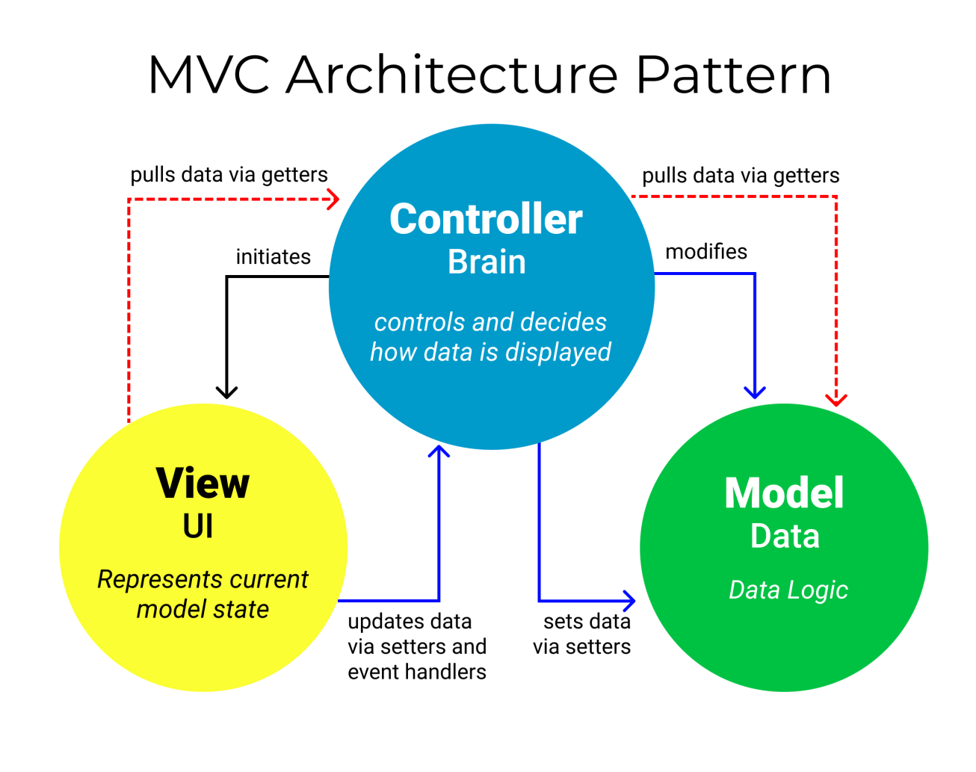
Figure 30: MVC diagram source (https://www.freecodecamp.org/news/the-model-view-controller-pattern-mvc-architecture-and frameworks-explained/)

II. DEPLOYMENT DIAGRAM
a) Definition
A deployment diagram is a structural diagram that illustrates the physical components and their relationships within a system. It showcases the topology of where the software components are deployed. This diagram includes nodes, which represent the physical hardware used to deploy and run the application.
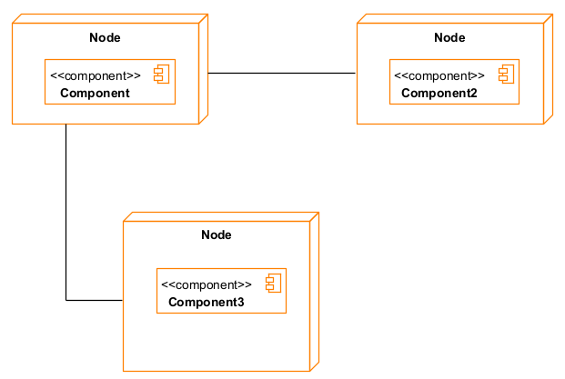
b) Formalism

Figure 31: Formalism of a Deployment Diagram

Table 20: Deployment Diagram Components
Elements | Notation | Description
Node | 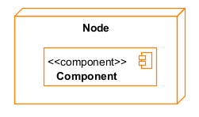 | It is a hardware used to deploy the application.
Artifact | 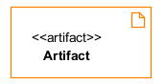 | An artifact is a major product, which is produced or used during the development of a software. E.g., diagrams, data models, setup scripts
Component | 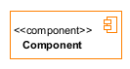 | It represents a modular part of a system that encapsulates its content and whose manifestation replaceable within its environment.
Association |  | An association helps to connect two nodes together which permits them to communicate together.

c) System Deployment Diagram
Figure 32: System Deployment Diagram
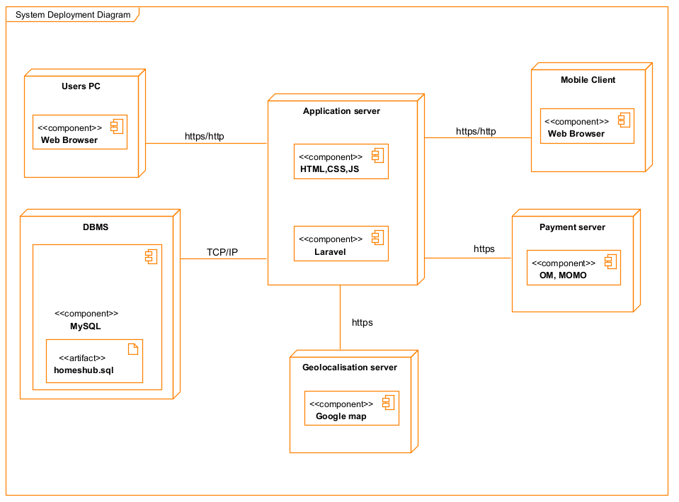

III. COMPONENT DIAGRAM
a) Definition
Component diagrams are utilized to depict the physical elements of a system. These elements include executables, libraries, files, documents, and more, which reside within a node. It is important to note that while the component diagram does not illustrate the system's functionality, it portrays the components involved in enabling those functionalities.
b) Formalism
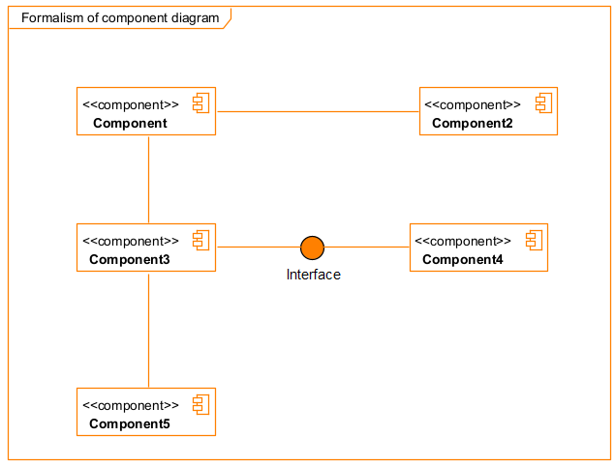
Figure 33: Formalism of a Component Diagram

Table 21: Component Diagram Components
Elements | Notation | Description
A component |  | A component is an abstract logical unit block of a system.
Dependency | 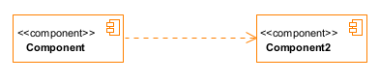 | Dependency is a directed relationship which is used to show that some components are dependent on others for their correct functioning.
Interface | 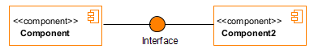 | An interface is a circle or a semi-circle attached to a stick which looks like a lollipop. It describes groups of operations provided or required by components.
Port | 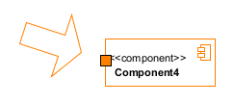 | A port (represented by a small square at the end of a required or provided interface) is used when the components delegate the interfaces to an internal class.

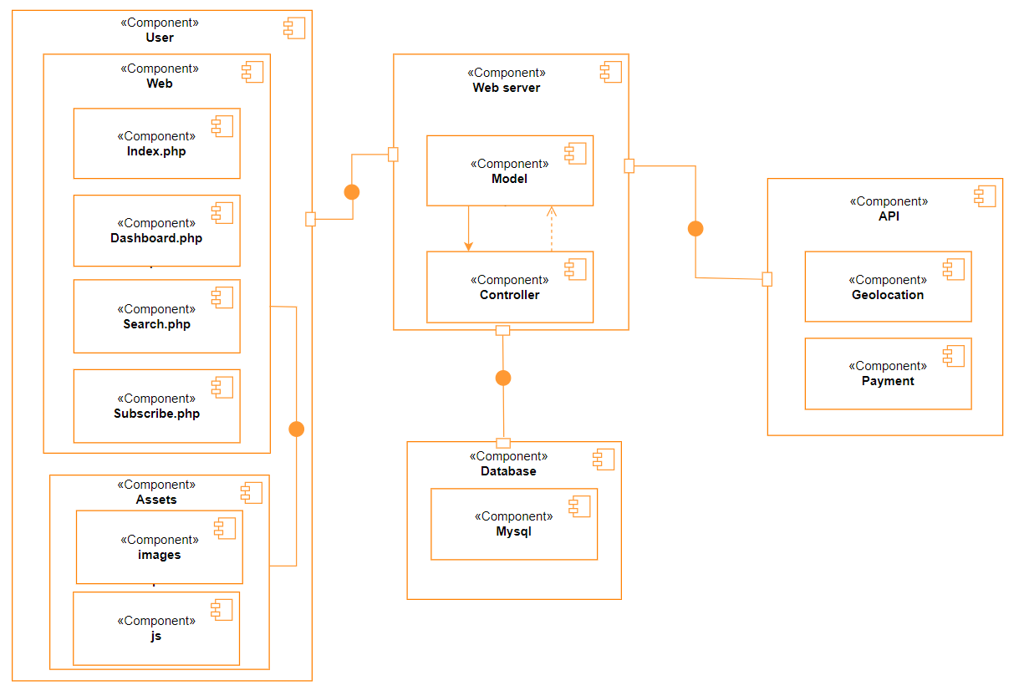
c) System Component Diagram
Figure 34: System Component Diagram

CONCLUSION
In our realization phase, we implemented our application. In other to accomplish this phase, we made used of our analysis and conception phase. We also drew the deployment and component diagrams which depict the structure of our system in terms of modules, files, assets, how the different elements interact with each other. We will move to the test of functionalities phase, where we will examine the different modules present in our app and how beneficial they are to its different users.

PART SEVEN

TEST OF FUNCTIONALITIES

Preamble

In this phase, we will present the various functionalities of our application.
Content overview

INTRODUCTION
- APPLICATION FUNTIONALITIES
- TEST SHOWCASES
CONCLUSION

INTRODUCTION
The test of functionalities phase helps us to know more about the solution we are building. It provides the different functionalities or modules found in our application and how they are beneficial to the users. Hence, in this phase we are going to explore the different functionalities present our application.

I. APPLICATION FUNCTIONALITIES
1. User Registration and Authentication:
- Secure registration and login system for all user types (Customers, Landlords/Agents, Administrators)
- Role-based access control and permissions
- Password recovery and profile management
2. Property Management:
- Create, edit, and delete property listings
- Upload multiple high-quality images and detailed descriptions
- Set availability status, pricing, and property features
- Admin verification system for new listings
3. Advanced Property Search:
- Comprehensive search with location-based filtering
- Advanced filters (price range, property type)
- Geolocation integration for nearby property discovery
- Saved searches and favorite properties functionality
4. Communication System:
- Secure in-platform messaging between users
- Direct contact between property seekers and owners
- Notification system for new messages and inquiries
- Contact history tracking

5. Subscription and Payment Management:
- Tiered subscription plans for landlords/agents
- Integration with local payment gateways (Orange Money, MTN MoMo)
- Payment history and subscription status tracking
- Automated renewal reminders
6. Administrative Dashboard:
- User account management and moderation
- Property listing verifcation
- Platform analytics and usage statistics
- System configuration and notification management
7. Notification System:
- New message alerts and platform updates
- Subscription status notifications
8. Additional Features:
- Property rating and review system
- Advanced filtering based on local amenities
- Responsive design for mobile and desktop access

II. TEST SHOWCASES
The following are tests carried out using postman on our APIs endpoints.
- Authentication model
Here we tested:
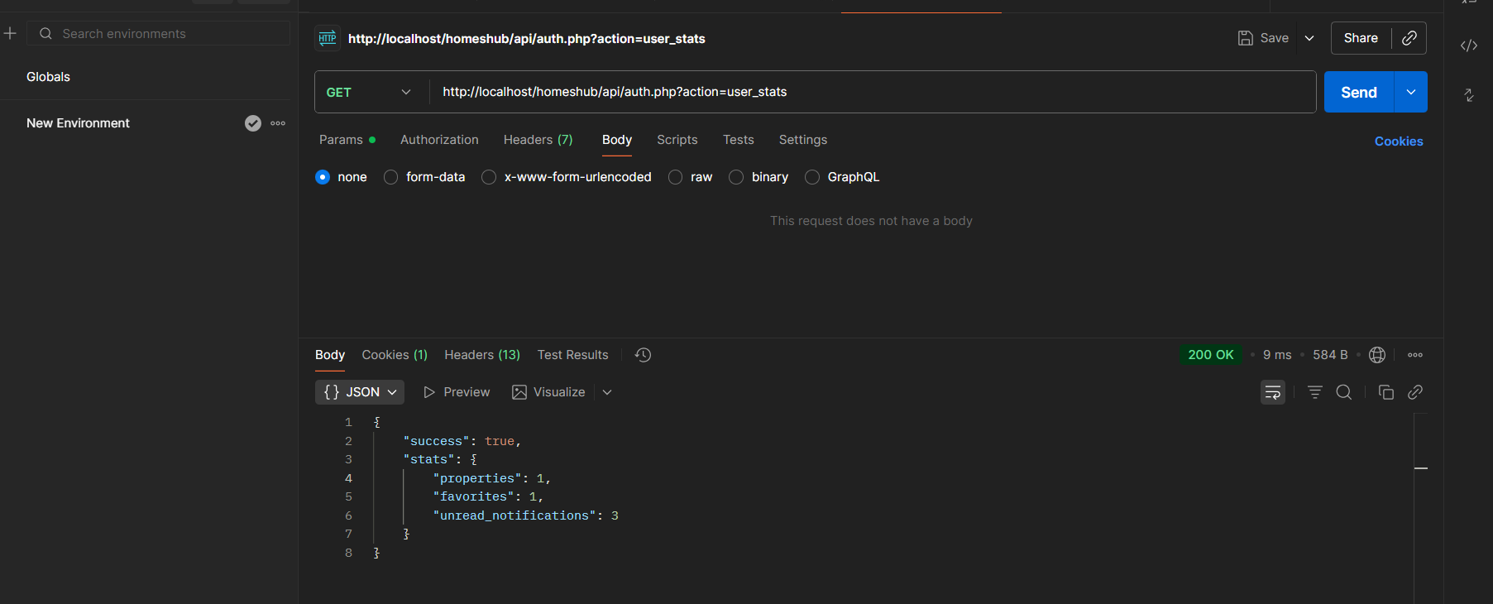
- /api/auth.php?action=user_stats routes that enables to get the user_stats.
Figure 35: GET user stats test

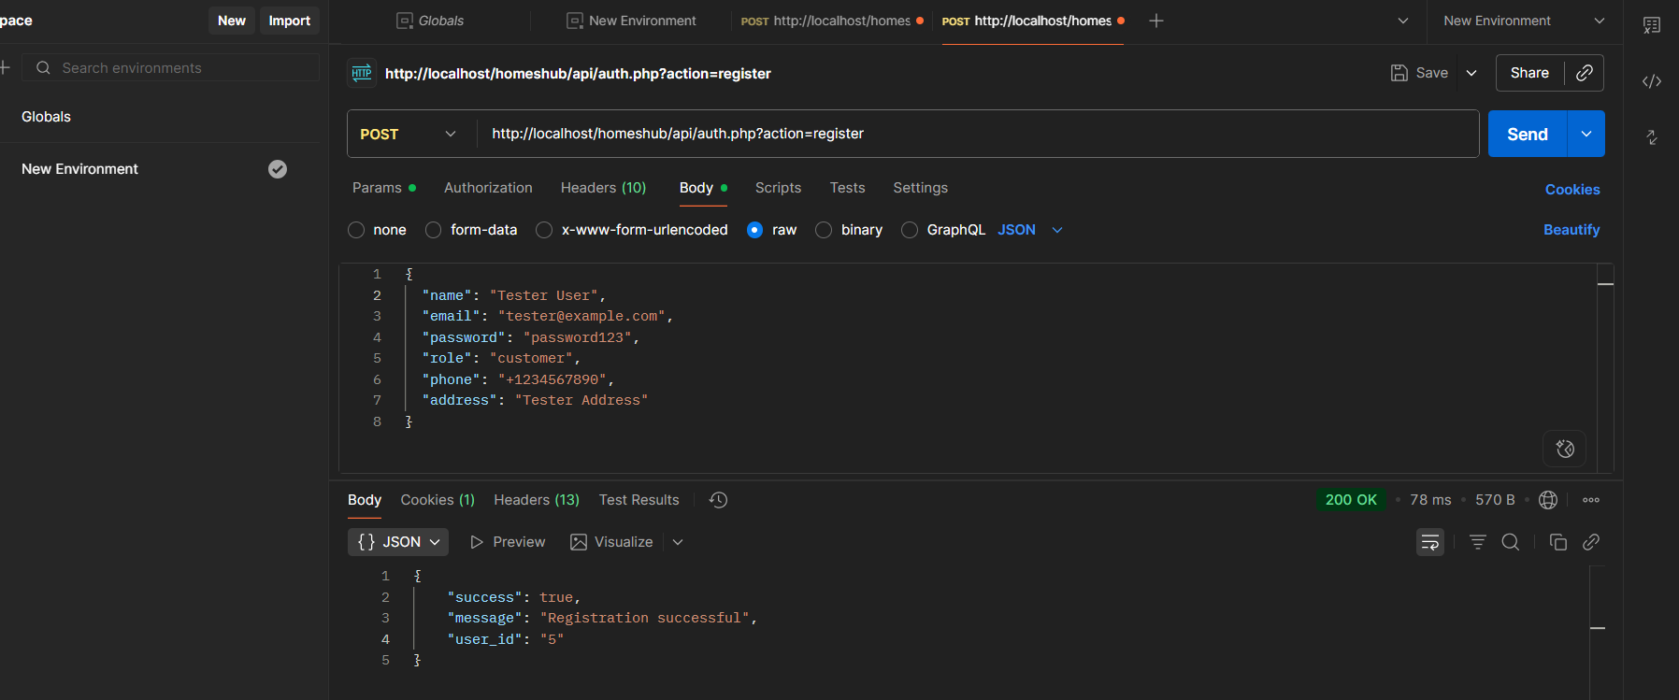
- /api/auth.php?action=register routes to test user registration.
Figure 36: POST user registration test
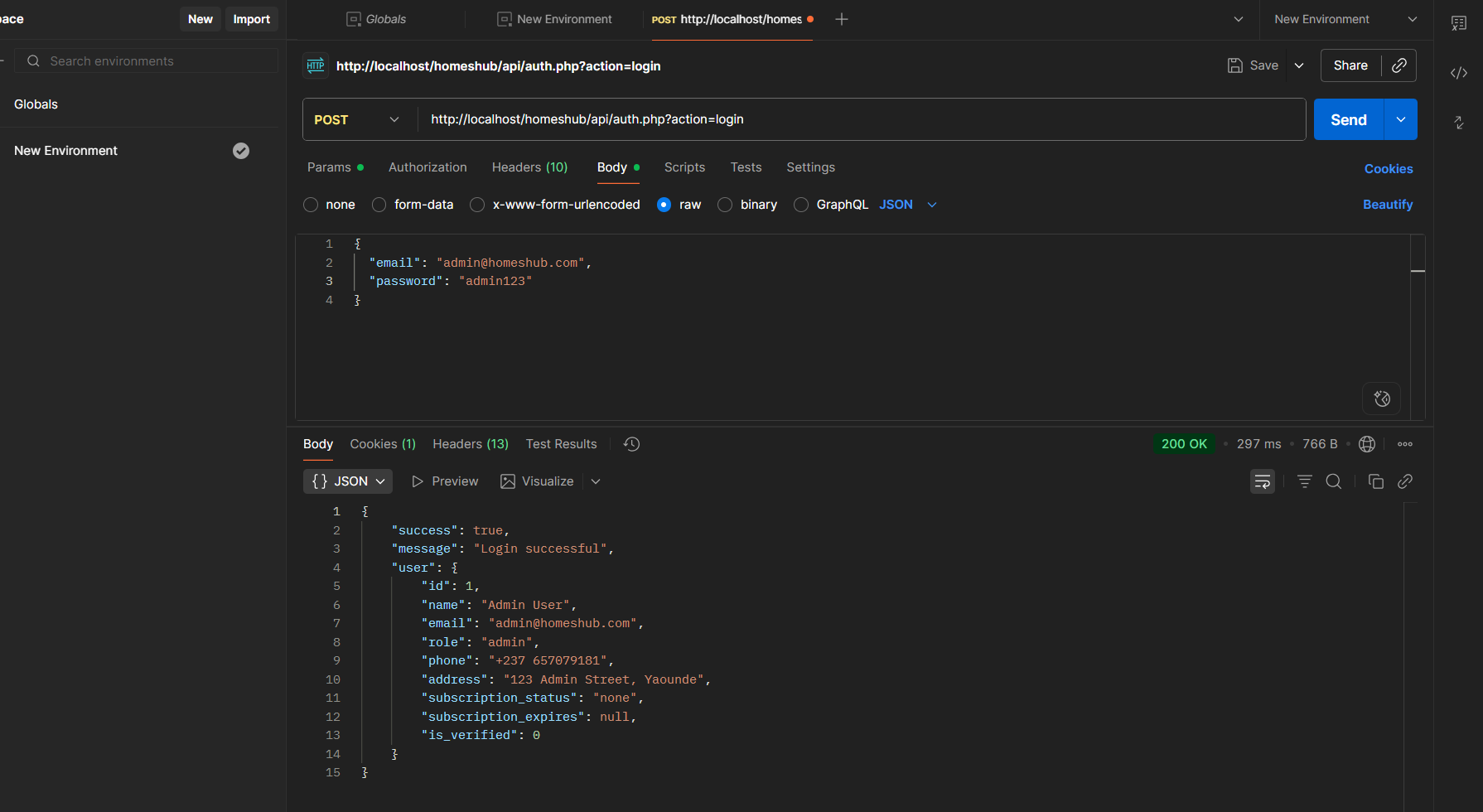
- /api/auth.php?action=login routes that enables to test login.
Figure 37: POST user login test

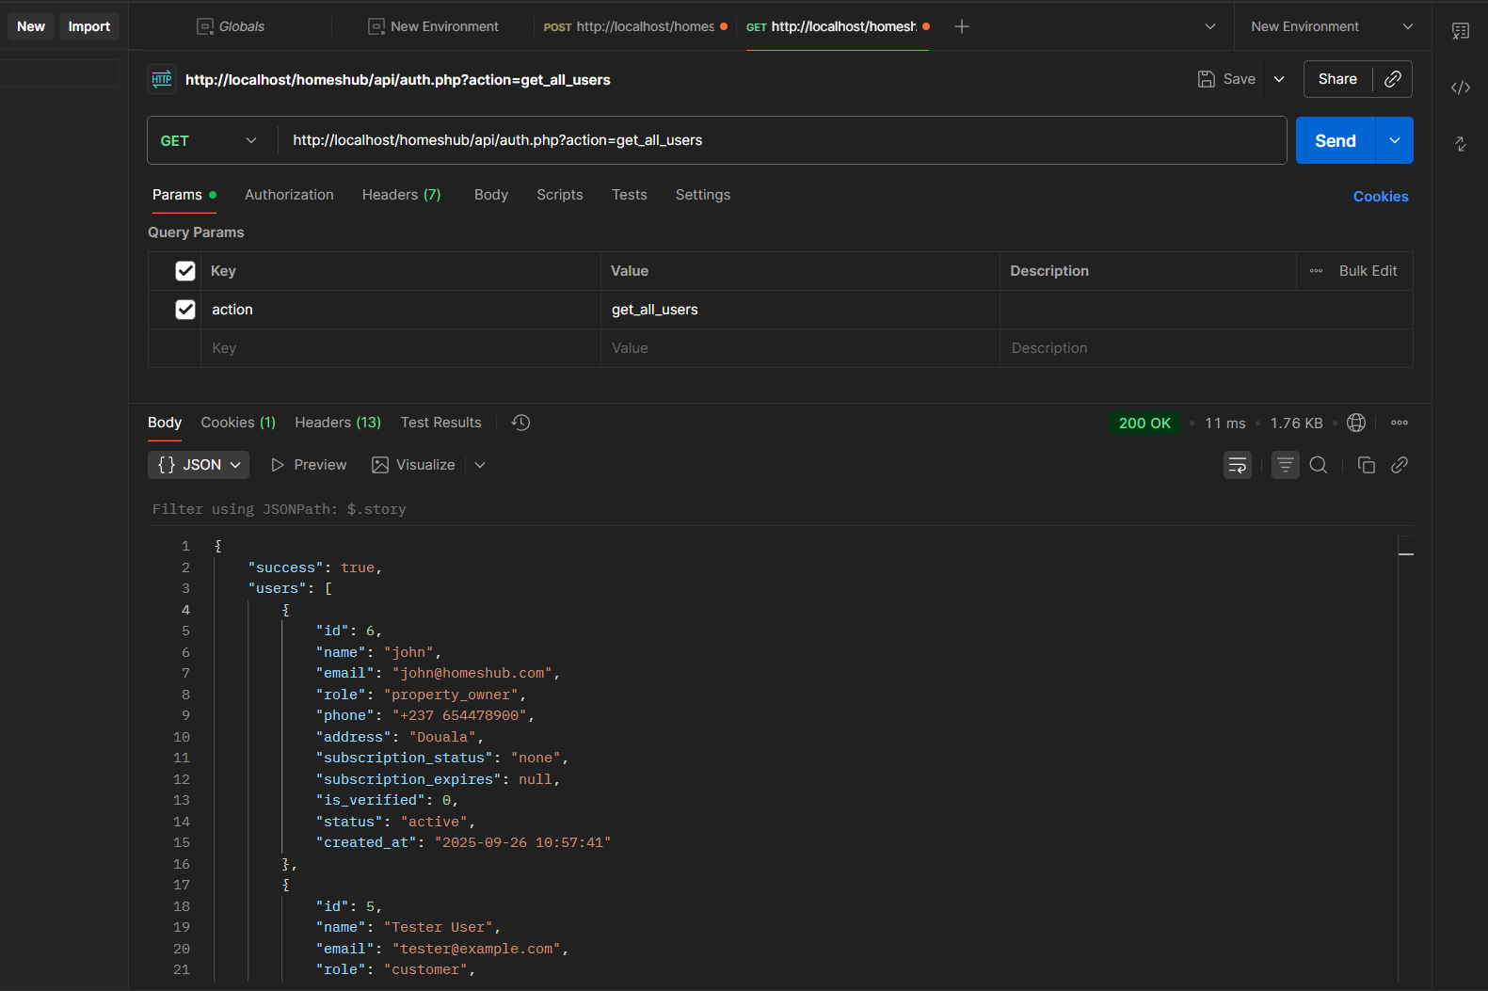
- /api/auth.php?action=get_all_users routes that enables to get all users and their information.
Figure 38: GET all user test
- Properties model
Here we tested:
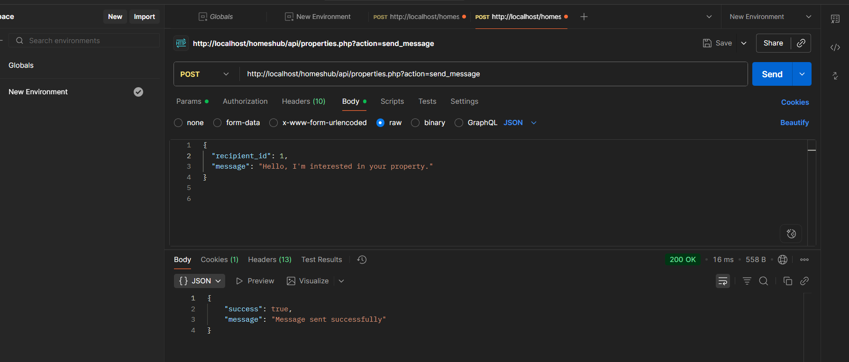
- /api/properties.php?action=send_message routes that enables to test the sending of messages.
Figure 39: POST send message test

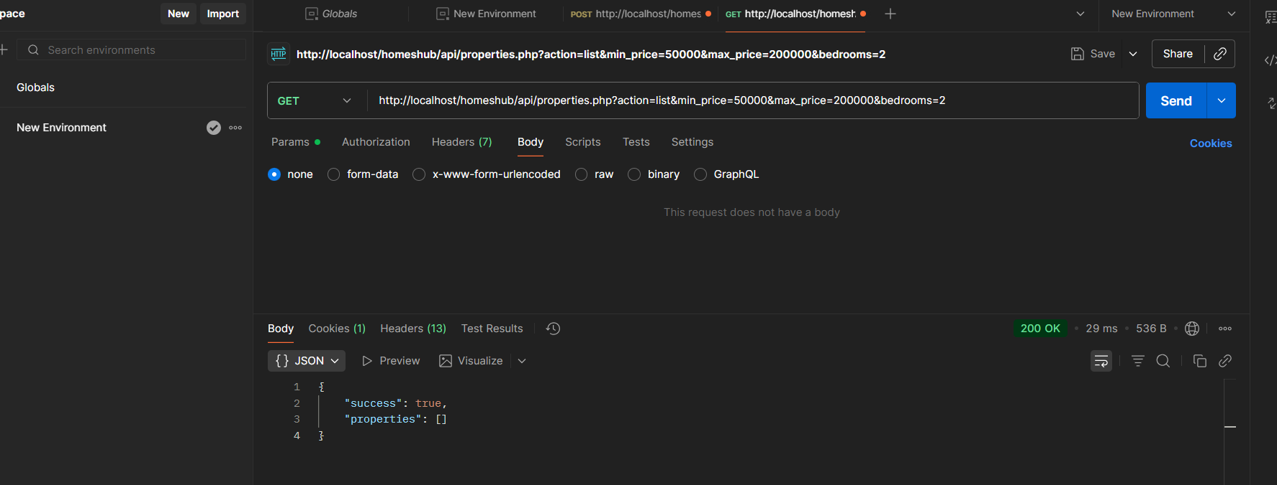
- /api/properties.php?action=list&min_price=50000&max_price=200000&bedrooms=2 routes that enables us to list properties based on criterias.
Figure 40: GET property test based on criteria

CONCLUSION
The testing phase successfully validated the core authentication and property management functionalities of HomesHub. Through rigorous testing of auth.php and properties.php endpoints, we confirmed secure user registration, login processes, and reliable property listing operations. These tests ensure that HomesHub's fundamental features operate correctly, providing a solid foundation for property transactions. The platform now reliably supports user account management and property discovery, meeting the essential requirements of our real estate solution. We now proceed to the installation and user guide phase, where we'll provide clear instructions for deploying and using HomesHub.

PART EIGHT

INSTALLATION AND USER GUIDE

Preamble

The purpose of the user guide is to provide users of our platform with step-by-step instructions on how to install and use the system.
Content overview

INTRODUCTION
I. INSTALLLATION
II. USER GUIDE
CONCLUSION

INTRODUCTION
This is the final phase of our report. In this phase we will walk through the requirements for our system, the necessary installation process, accessing our system and its features, all this in a step-by-step manner to facilitate the setting up of the platform for the first-time users. The steps of different processes will be accompanied by images. After we will showcase our application by viewing the different screens.

I. INSTALLATION OF THE APPLICATION
A. Prerequisites (Software Requirements)
- Operating System: Windows 10/11, macOS, or Linux
- Web Server: XAMPP, WAMP, or Laragon (includes Apache and MySQL)
- PHP: Version 8.1 or higher (required by Laravel)
- Composer: PHP dependency manager (https://getcomposer.org)
- Database: MySQL (included in XAMPP/WAMP)
- Web Browser: Google Chrome, Mozilla Firefox, or Microsoft Edge (latest versions)
- Code Editor: Visual Studio Code (recommended)
B. Installation Steps
- Setup Local Server Environment:
  - Download and install XAMPP from https://www.apachefriends.org
  - Start the Apache and MySQL modules from the XAMPP Control Panel
  - Install Composer globally on your system from https://getcomposer.org
- Extract and Configure Project Files:
  - Obtain the Homeshub project source code (ZIP file or Git repository)
  - Extract all files to your web server directory: C:\xampp\htdocs\homeshub
  - Open command prompt and navigate to the project directory:
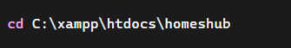

- Install Laravel Dependencies:
- Environment Configuration:
  - Copy the .env.example file to .env:
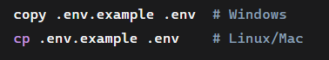
  - Generate application key:
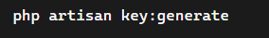
  - Edit the .env file with your database configuration:
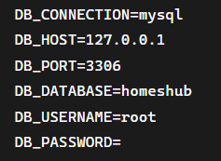
- Configure Frontend Assets:
  - The frontend uses vanilla JavaScript, CSS, and HTML files located in:
    - Views: resources/views/
    - JavaScript: public/js/
    - Images: public/images/
  - No additional frontend build process is required since vanilla technologies are used
- Create and Configure the Database:
  - Open phpMyAdmin at http://localhost/phpmyadmin
  - Create a new database named homeshub
  - Run database migrations:
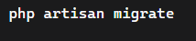
  - Seed the database with initial data (if available):
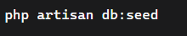
- Configure Storage for File Uploads:
- Set File Permissions (Linux/Mac only):
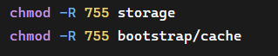
- Run the Application:
  - Start the Laravel development server:
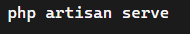
  - Open your browser and navigate to http://localhost:8000
  - Alternatively, you can access via XAMPP: http://localhost/homeshub/public

II. USER GUIDE
A. For Property Seekers (Customers)
- Registration & Login:
  - On the homepage, click "Register".
  - Fill in the form, select "I am looking for a property" (Customer role), and submit.
  - Then log in with your email and password.
- Searching for a Property:
  - Use the search bar on the top of the dashboard. You can type a location (e.g., "Douala, Bonanjo").
  - For more precise results, use the filters to specify price, property type, etc.
  - Click "Search" to view matching properties as a list or on a map.
- Viewing Details and Contacting:
  - Click on any property card to see its full details: description, gallery, location map, and owner info.
  - To inquire, click the "Contact Owner" button. This opens the in-platform messaging system.
  - Type your message and send it. The landlord will receive a notification and can reply within the platform.
B. For Property Owners/Landlords
- Listing a Property:
  - Log in with a property owner account.
  - Go to your dashboard and click "Add New Property".
  - Fill out the form thoroughly: title, detailed description, address, price, and upload clear photos then submit the listing.
- Managing Subscriptions:
  - Navigate to the "Subscription" page from your dashboard.
  - Choose a plan that fits your needs and click "Subscribe".
  - You will be redirected to a payment gateway (MoMo/OM) to complete the transaction. Once confirmed, your listing limits will be updated.
- Managing Inquiries:
  - When a customer sends a message, you will see a notification in your dashboard.
  - Go to the "Messages" section to view and respond to all inquiries directly.
C. For Administrators
- Managing Users and Listings:
  - Access the admin dashboard via the dedicated login URL or panel.
  - Use the "Users" section to view, activate, or deactivate user accounts.
  - Use the "Listings" section to review all properties.

SHOWCASES
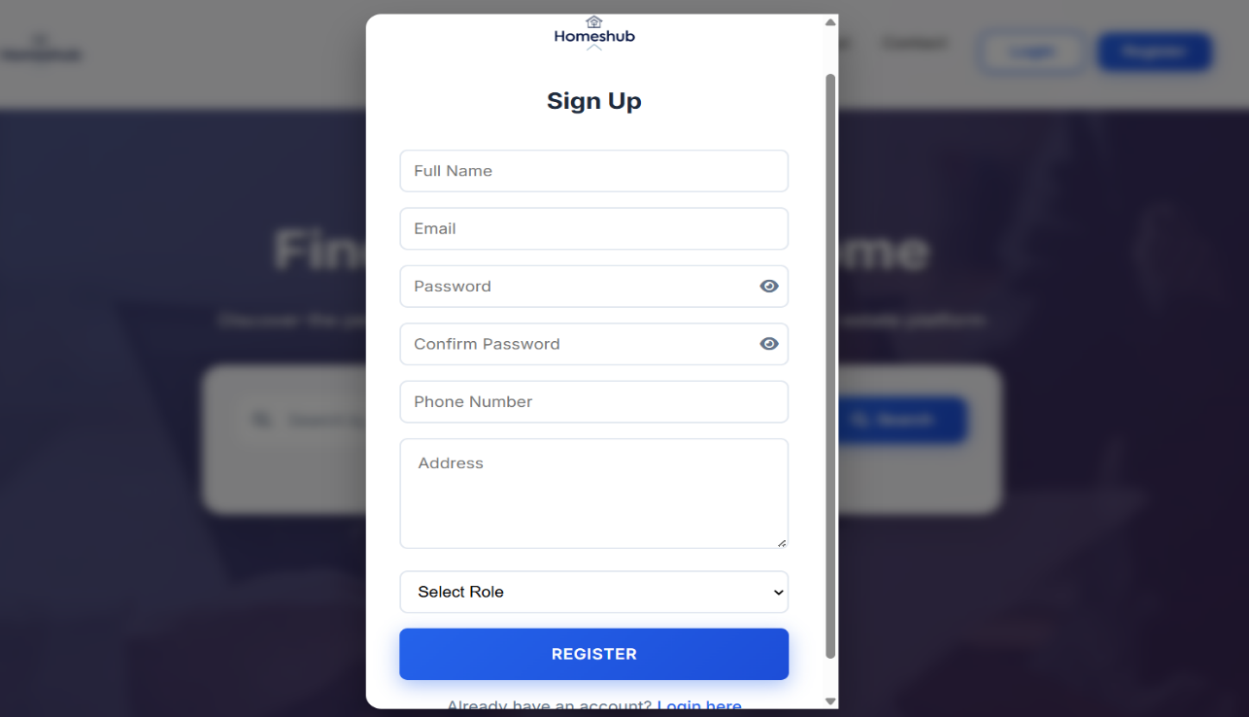
- Here we have the register screen
Figure 41: Registration screen

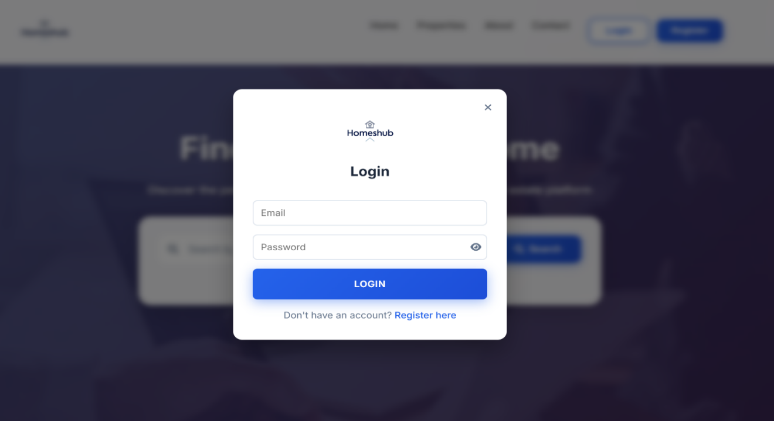
- This is the login screen
Figure 42: Login screen

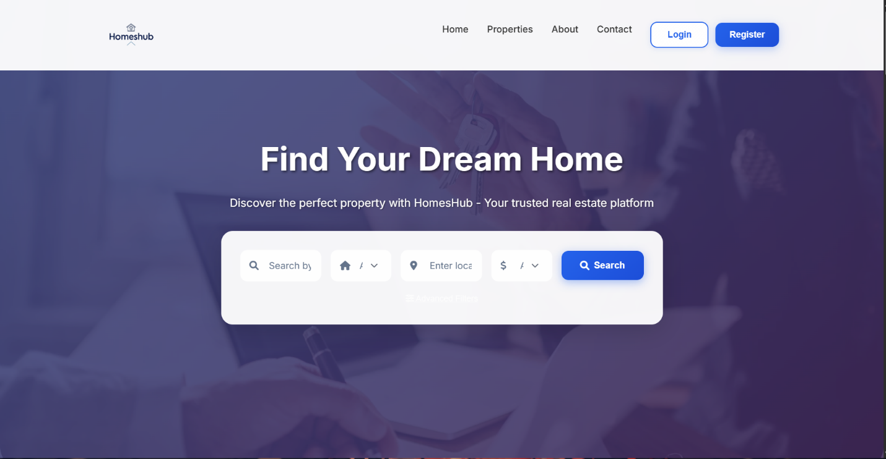
- Here we have our Homepage
Figure 43: Homepage

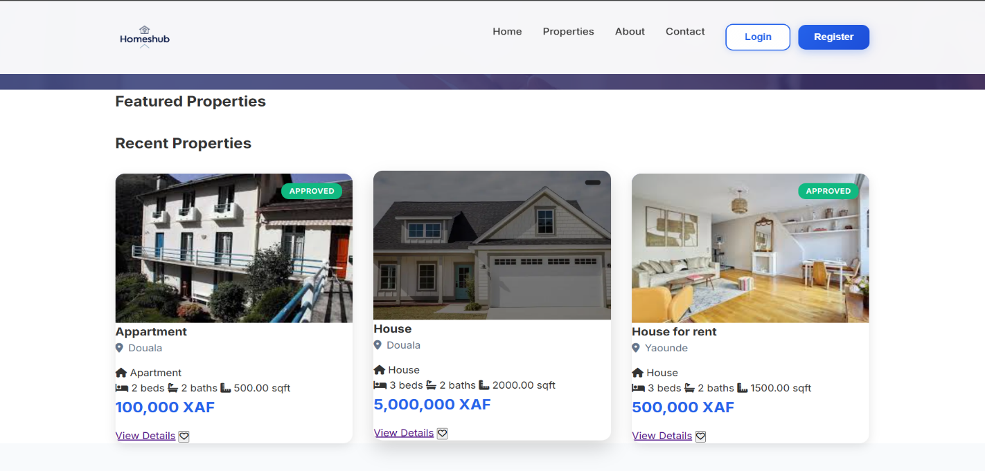
- Properties page
Figure 44: Properties page

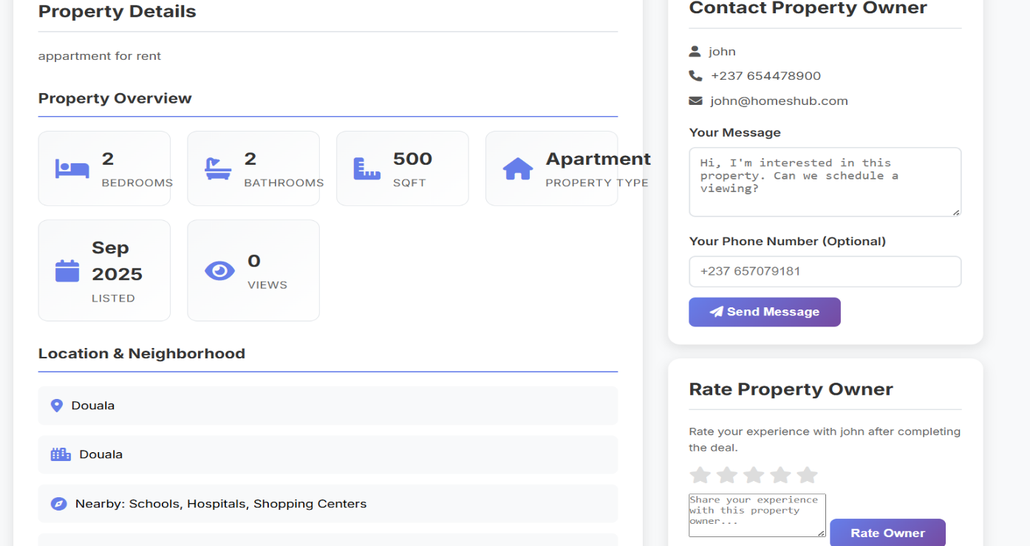
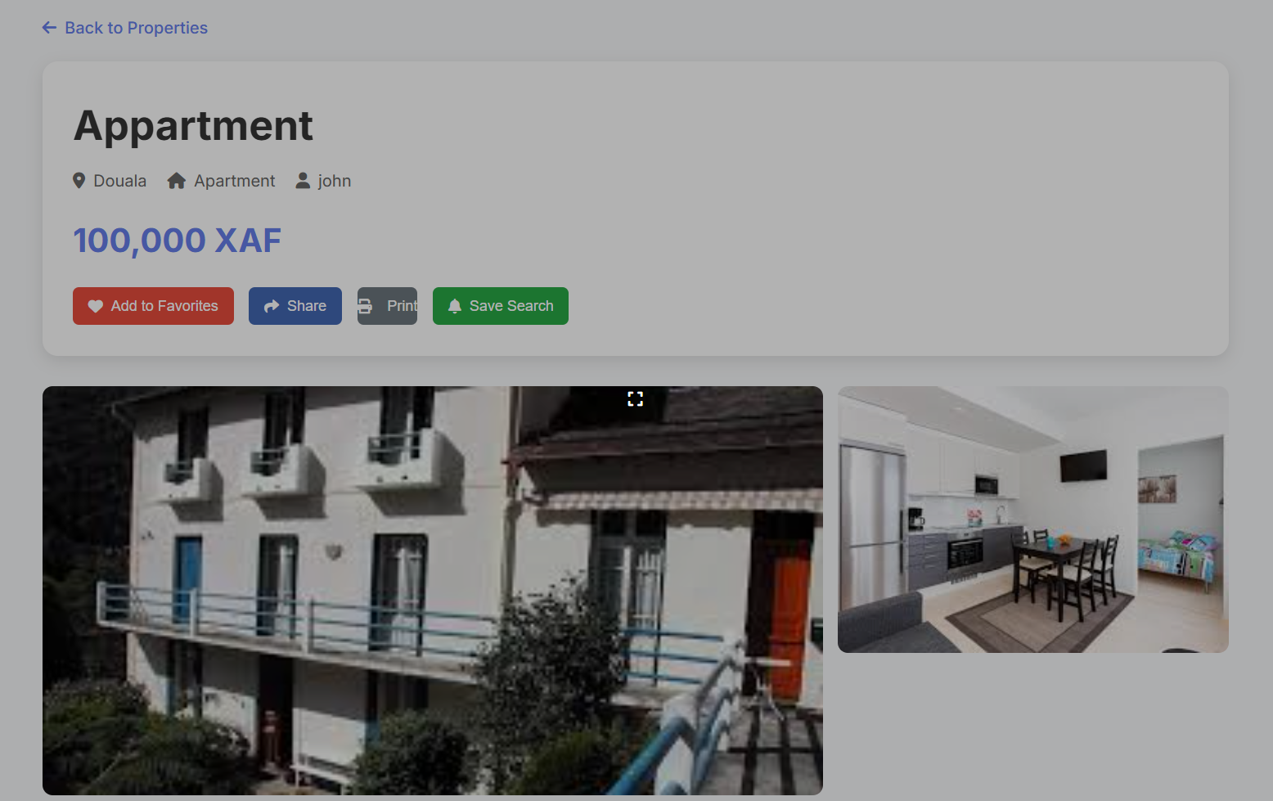
- View property detail interface
Figure 45: View property detail interface

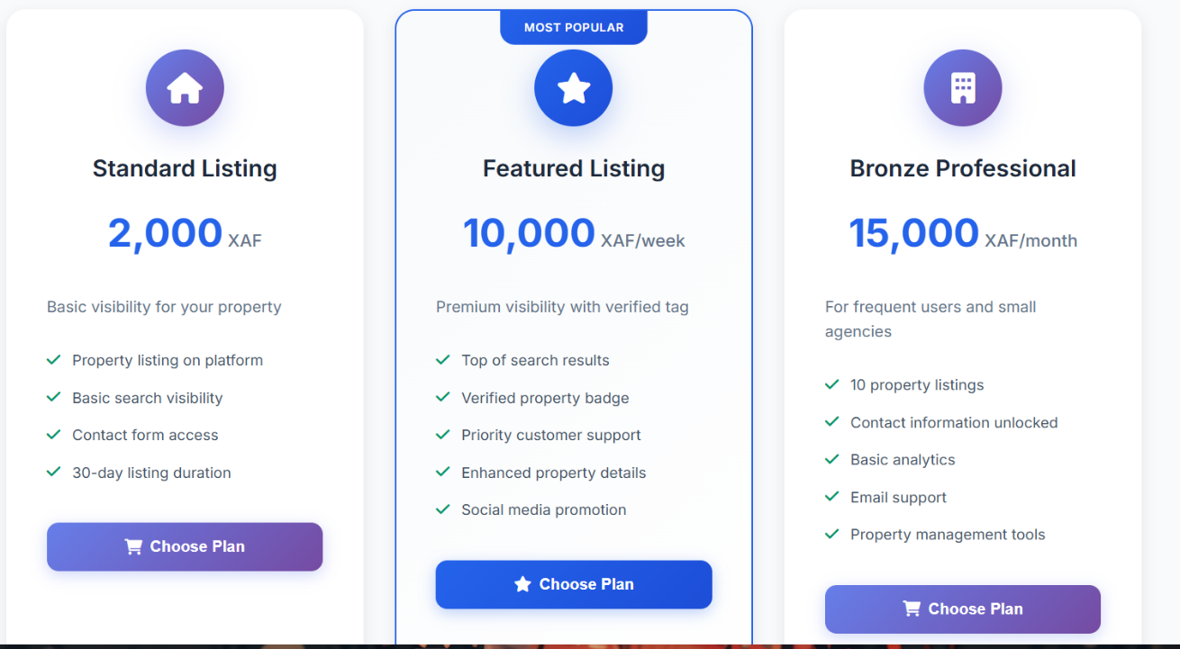
- Subscription plans page
Figure 46: Subscription plans page

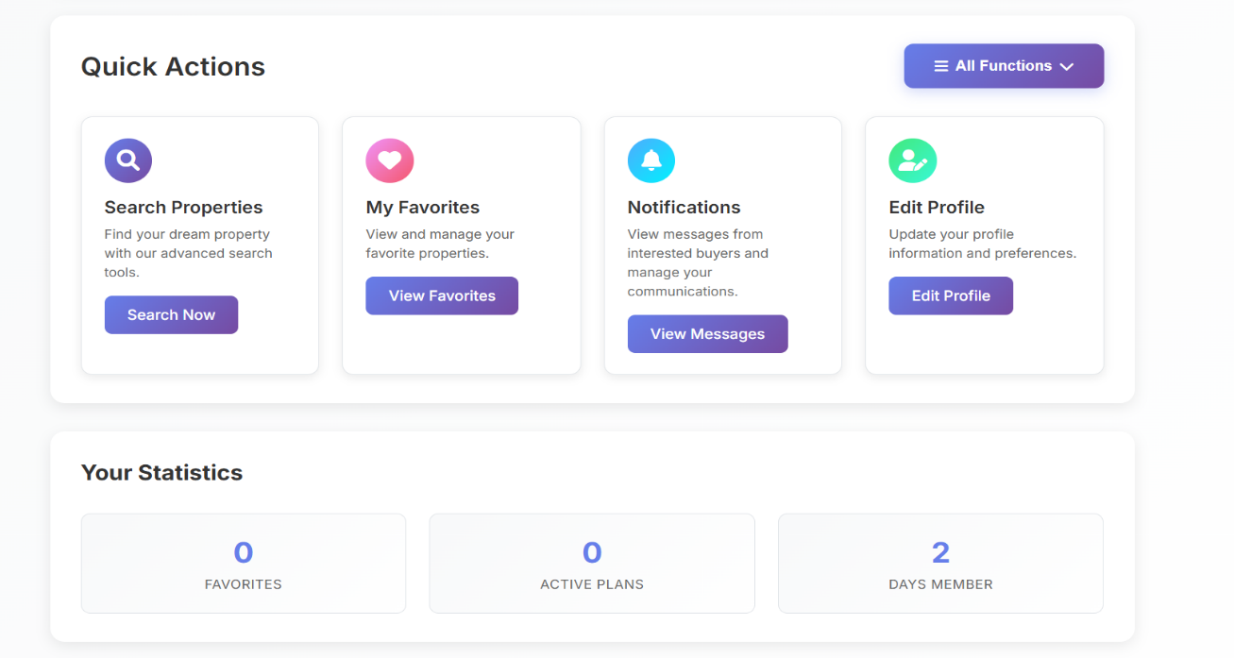
- Customer Interfaces

Figure 47: Customer dashboard

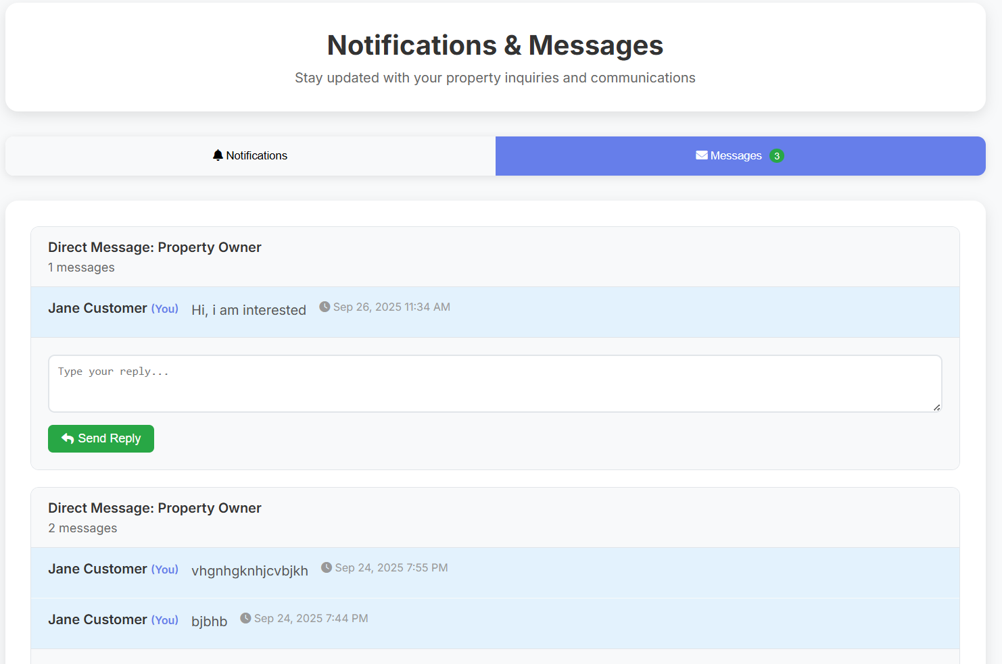
Figure 48: Notification page

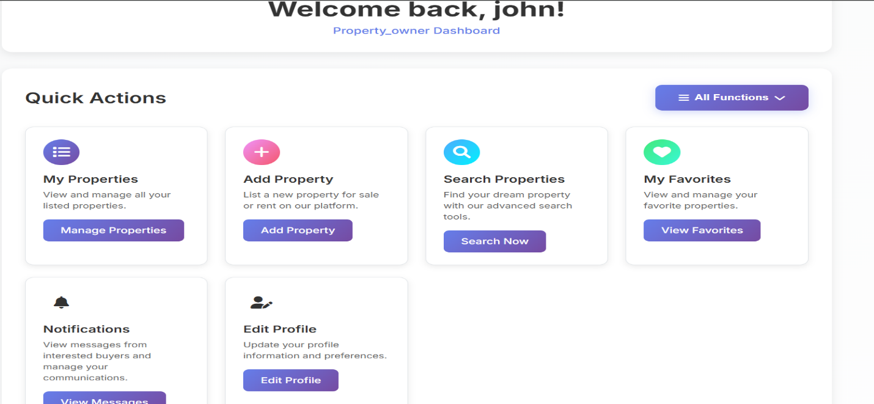
- Property owner Interfaces
Figure 49: Property owner dashboard

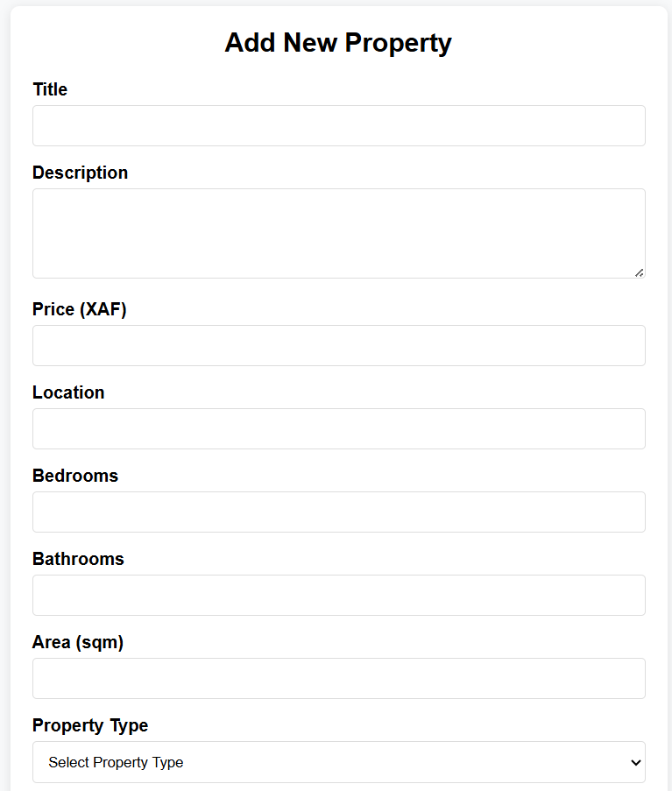
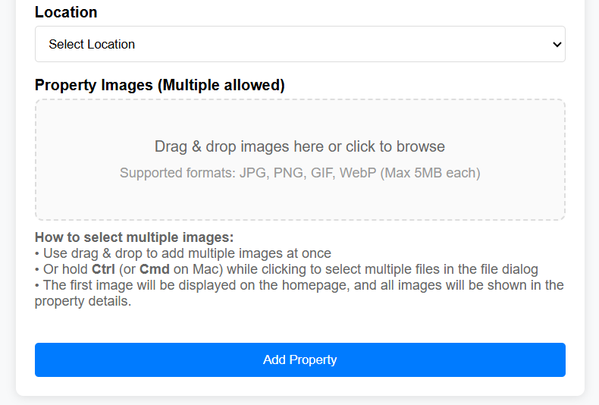

Figure 50: Add property form

- Admin interfaces
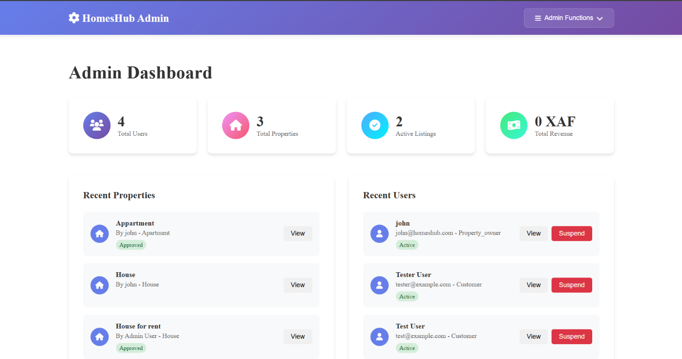
Figure 51: Admin dashboard

CONCLUSION
Once the platform is set up, it is essential to provide a manual to assist its various users. Therefore, we have outlined the different tools required for installation and detailed the installation process to ensure the application runs smoothly. Additionally, we will explain how users can effectively navigate and utilize the platform once the environment is fully configured. This manual will serve as a comprehensive guide to maximize the user experience.

GENERAL CONCLUSION

GENERAL CONCLUSION

The Homeshub project successfully modernizes Cameroon's real estate sector by creating a centralized digital platform that eliminates the inefficiencies of traditional property searches. The platform directly addresses key challenges including fragmented listings, fraudulent practices, and lack of transparency through verified property listings, advanced search filters, and secure user authentication. By providing a structured marketplace with integrated messaging and subscription management, Homeshub bridges the gap between property owners and seekers, saving users time and reducing financial risks. This project demonstrates the effective application of digital technology to solve real-world local problems, establishing a foundation for trust and professionalism in Cameroon's real estate market.

ANNEXE

BIBLIOGRAPHY

BIBLIOGRAPHY

- Mr. MESSIO Ulrich UML course AICS-Cameroon 2024-2025
- Mr. ASANE Derick PHP course (Web programming 2) AICS-Cameroon 2024-2025
- Mrs. TCHOUTOUO Isabelle Scientific Writing course AICS-Cameroon 2024-2025
- Report of the student NDONGO BELANGUE-NKENG JOSEPHA LA GRACE ONLINE HAIR SALON BOOKING SYSTEM 2023-2024
- Mercurial-2025

WEBOGRAPHY

WEBOGRAPHY

- https://www.w3schools.com/tags/ref_httpmethods.asp visited many times for code debugging and project development
- https://www.visual-paradigm.com/tutorials/how-to-draw-deployment-diagram-in-uml/ How to draw a deployment diagram. August 8th 2025 4:28 AM.
- https://www.scribbr.com/dissertation/abstract/ What is an abstract? July 10th 2025 5:30 PM.
- https://advice.writing.utoronto.ca/planning/intros-and-conclusions/#:~:text=A%20good%20introduction%20should%20identify,in%20a%20somewhat%20wider%20context How to write a good introduction. July 20th 2025
- https://fr.wikipedia.org/wiki/Two_Tracks_Unified_Process Two Track Unified Process. August 3rd 2025 12:30 AM
- https://laravel.com/ August 1st
- https://www.youtube.com/results?search_query=laravel+tutorial visited numerous times to learn how to use Laravel.
- https://www.youtube.com/results?search_query=api+testing+using+postman How to test APIs using postman. September 20th 6:45 PM

TABLE OF CONTENT

TABLE OF CONTENT

DEDICATION i
ACKNOWLEDGEMENT ii
SUMMARY iii
LIST OF FIGURES v
LIST OF TABLES vii
LIST OF ABBREVIATIONS viii
ABSTRACT ix
RESUME x
GENERAL INTRODUCTION 1
PART ONE 2
INSERTION PHASE 2
INTRODUCTION 4
I- WELCOME AND INSERTION 5
II- GENERAL REPRESENTATION OF SHADERL 6
III- ORGANISATION OF SHADERL 8
IV- GEOGRAPHICAL LOCATION 11
V- BRIEF PRESENTATION OF THE PROJECT THEME 12
CONCLUSION 13
PART TWO 14
EXISTING SYSTEM 14
INTRODUCTION 16
I. PRESENTATION OF THE PROJECT THEME 17
II. STUDY OF THE EXISTING SYSTEM 18
III. CRITICISMS OF THE EXISTING SYSTEM 20
IV. PROBLEMATIC 21
V. PROPOSED SOLUTION 21
CONCLUSION 22
PART THREE 23
THE SPECIFICATION BOOK 23
INTRODUCTION 25
I. CONTEXT AND JUSTIFICATION 26
II. OBJECTIVES OF THE PROJECT 27
III. EXPRESSION OF NEEDS 28
IV. PROJECT PLANNING 30
V. ESTIMATED COST OF THE PROJECT 32
VI. CONSTRAINTS 35
VII. LIST OF PARTICIPANTS AND DELIVERABLES 36
CONCLUSION 37
PART FOUR 38
ANALYSIS PHASE 38
INTRODUCTION 40
I. METHODOLOGY 41
II. MODELLING OF THE SYSTEM 49
CONCLUSION 74
PART FIVE 75
CONCEPTION PHASE 75
INTRODUCTION 77
I. CLASS DIAGRAM 78
II. STATE MACHINE DIAGRAM 81
III. PACKAGE DIAGRAM 84
CONCLUSION 87
PART SIX 88
REALIZATION PHASE 88
INTRODUCTION 90
I. ARCHITECTURE USE 91
II. DEPLOYMENT DIAGRAM 94
III. COMPONENT DIAGRAM 97
CONCLUSION 100
PART SEVEN 101
TEST OF FUNCTIONALITIES 101
INTRODUCTION 103
I. APPLICATION FUNCTIONALITIES 104
II. TEST SHOWCASES 106
CONCLUSION 109
PART EIGHT 110
INSTALLATION AND USER GUIDE 110
INTRODUCTION 112
I. INSTALLATION OF THE APPLICATION 113
II. USER GUIDE 116
CONCLUSION 125
GENERAL CONCLUSION 126
ANNEXE xi
BIBLIOGRAPHY xii
WEBOGRAPHY xiii
TABLE OF CONTENT xiv

